
Click for Terms & Conditions

BMW R1200GS 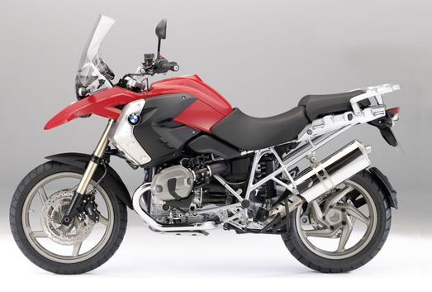Rate: R1400.00 per day
Including:
- Variable top box
- 700 km per day
- Comprehensive
Insurance
(T&C apply)

Accessories:

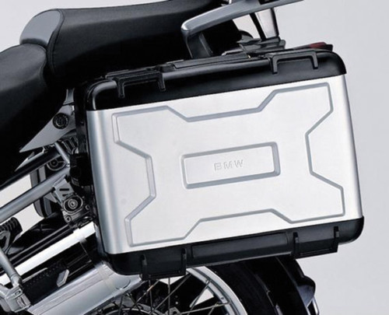
BMW Variable Panniers
Rate: R75.00 per day per set

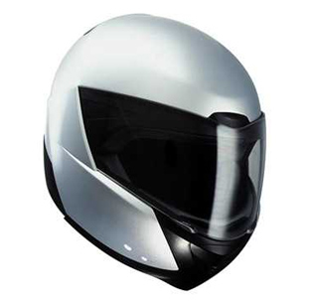

System 5 Helmet Rate: R50 per day
When available. (It is recommended
that Clients use their own)

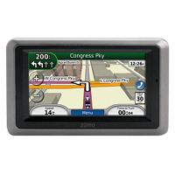
Garmin Zumo 660 GPS
Rate: R190.00 per day

Other rates:
- Booking deposit: 30% of total rental
- Rental deposit: R7500.00 per bike
- All rates mentioned include VAT
- Additional km charge: R0.80/km

