Ladies Ride - Great trip!
by DaveS on 10th August 2008, 17:16
Thanks to all for the ride this weekend - was great!!
_________________
When I was born I was so surprised I didn't talk for a year and a half!
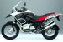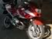
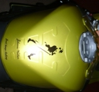
DaveS
Committee member

Re: Ladies Ride - Great trip!
by JR on 10th August 2008, 19:35
Thank you to the ladies for allowing me on their trip.
Quite a revelation………across the spectrum.
Your gals were great and did exceptionally well
Big up to :
Trudie (front), Dot (back)…….and all in between……Stienie, Dani, Maureen, Lynn, Anne, Jeanne, Corlia and Isolde (back up)
_________________
Let's go forward........the road is calling anyway
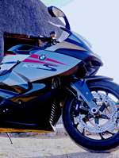
JR
The K-factor

Ladies Trip
by szalek on 10th August 2008, 19:59
I just want to say Well done, to all the ladies that Did the ladies ride.It was great and fun.
Lets do it again next year.
Gentleman,All that I can say is" get your bags packed with the Misses for next year".
Thank you to all the Ladies.Great job.
szalek
Supercharged

Re: Ladies Ride - Great trip!
by DaveS on 10th August 2008, 20:35
The ladies
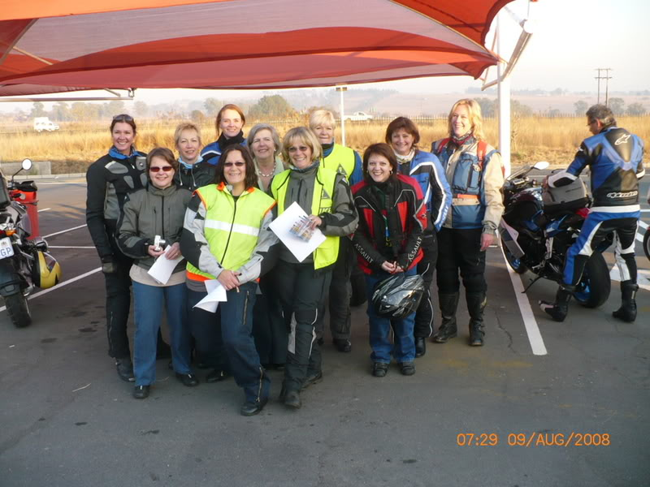
Breakfast at Turning Point Restaurante
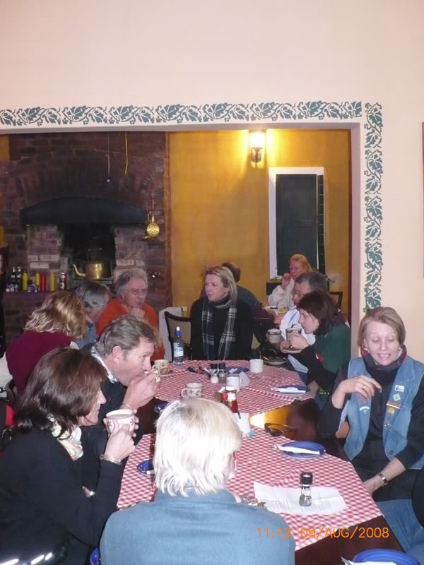
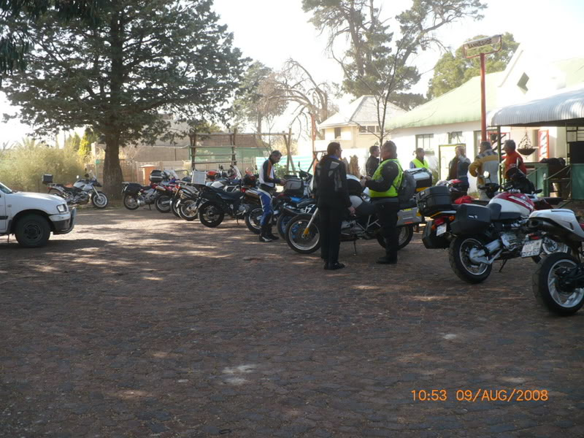
Stop in Amalia
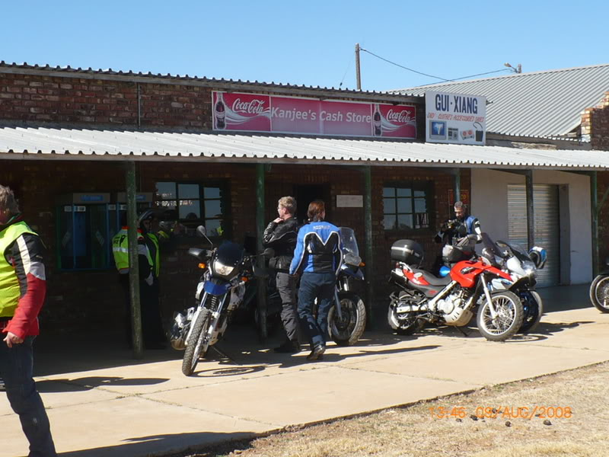
Relaxing at Christiana
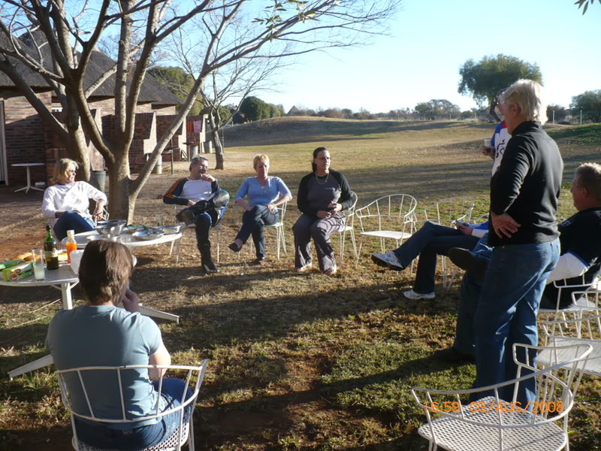
Dinner
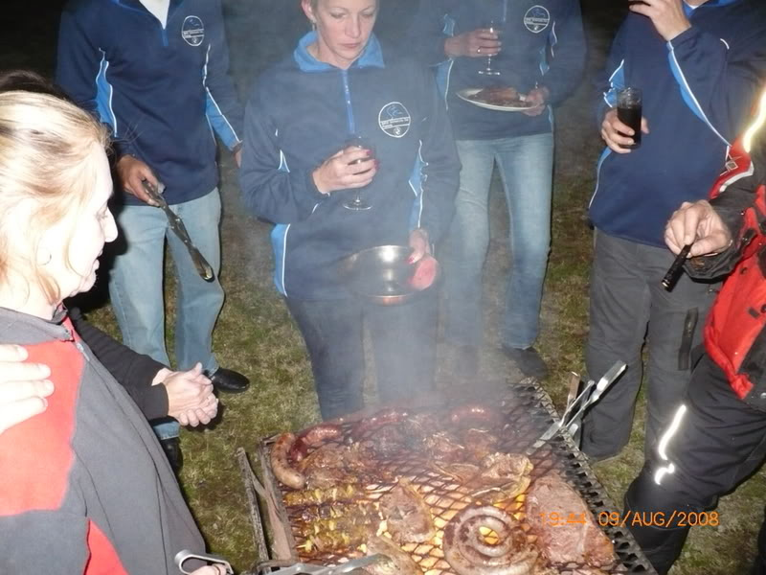
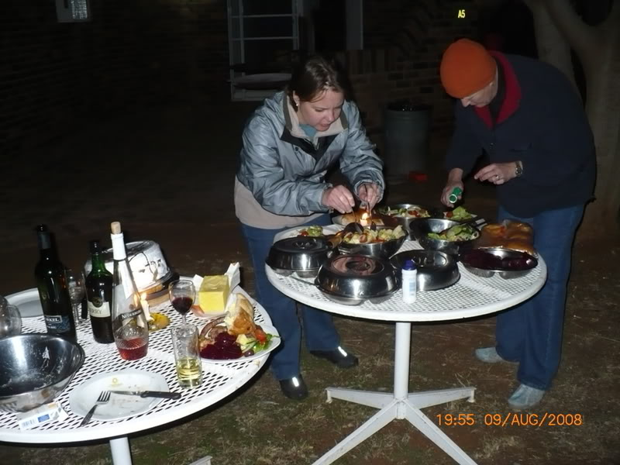
Fireside chat
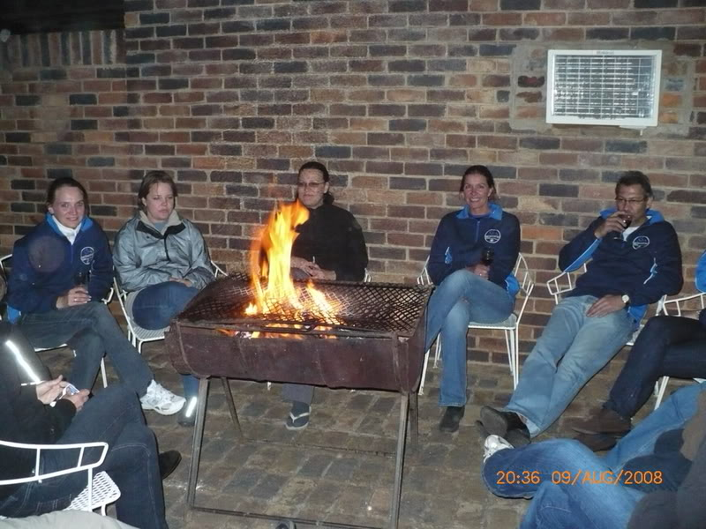
Dessert...the ladies being served.
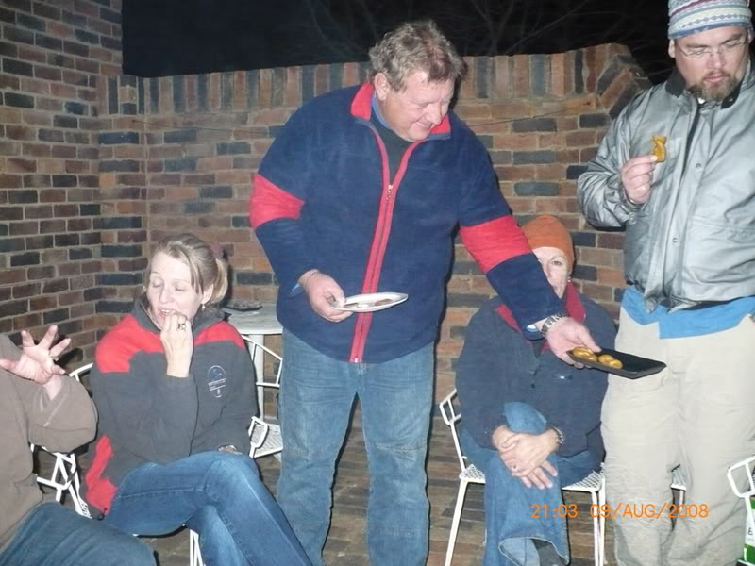
On the way home
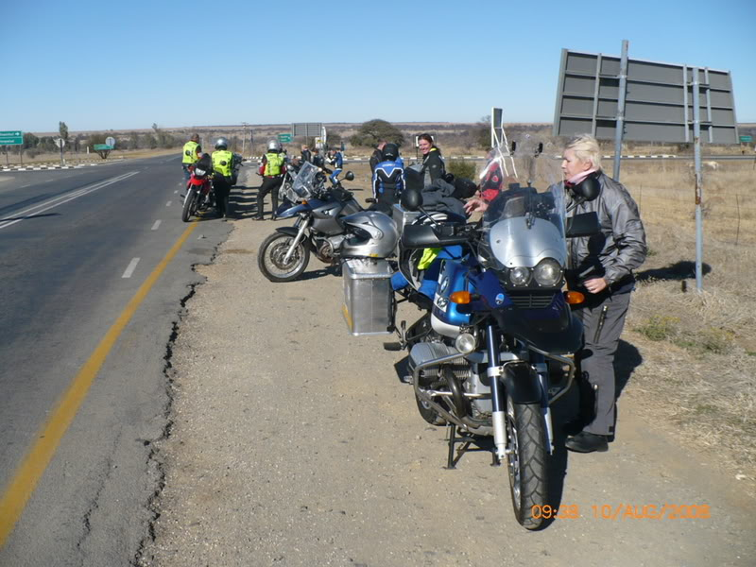
Lunch in Parys
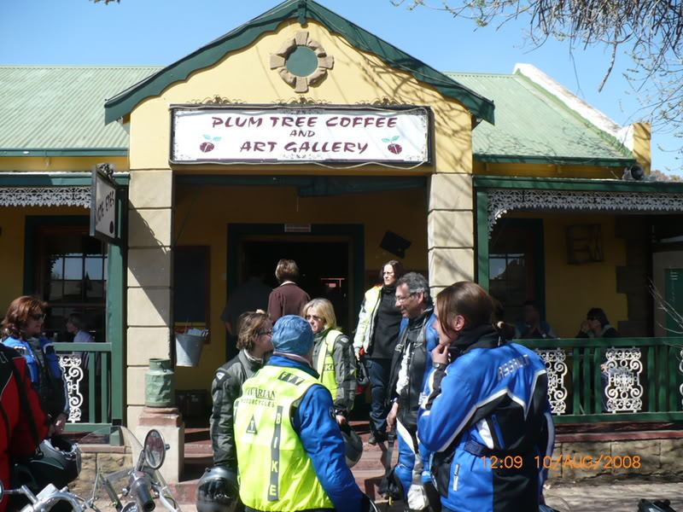
...and that, as they say, is that!!
_________________
When I was born I was so surprised I didn't talk for a year and a half!
DaveS
Committee member

Number of posts: 1281
Location: Centurion
My bike: R1200GSA: R1200S(I think - has been annexed by Dorothy): S1000RR
Registration date: 2008-07-28

Re: Ladies Ride - Great trip!
by JR on 11th August 2008, 09:51
nice pics, thanks for sharing.
now.......ladies of the open road.......let's hear from you........please
_________________
Let's go forward........the road is calling anyway
JR
The K-factor

Number of posts: 1164
Location: Gauteng
My bike: K1300S, F800GS
Registration date: 2008-06-02

Re: Ladies Ride - Great trip!
by tj on 11th August 2008, 10:20
Thanks to everyone for the support. From Isolde and me a very big thank you for a most enjoyable trip. I think I will start packing after washday for the next Ladies Ride.
My vinger in die pie..
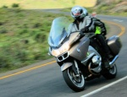
tj
Senior Contributor

Number of posts: 646
Age: 55
Location: Bapsfontein Area
My bike: K1300GT
Registration date: 2008-06-02

Re: Ladies Ride - Great trip!
by JR on 11th August 2008, 13:06
Steyngert wrote elsewhere........
"Living one's passion adds to you as a person, adds to the memories you will hold when you are no longer capable to do whatever you want to. To be able to live, you need to feel alive. To feel alive, you need to continuously depart from the comfort zone you have created for yourself"
With this in mind, let’s follow a slightly different approach in giving a photo essay account of the ladies trip by showing all the places that were visited on the trip. It should help to hold the memories as some of the places on this trip, will most likely never be visited again by some of us and btw, what better example of "you need to continuously depart from the comfort zone you have created for yourself" than the ladies on the trip.......especially the ones who did it as a first trip.
Apologies where the same bike appears again and again at some of the road signs
depature point on the N14
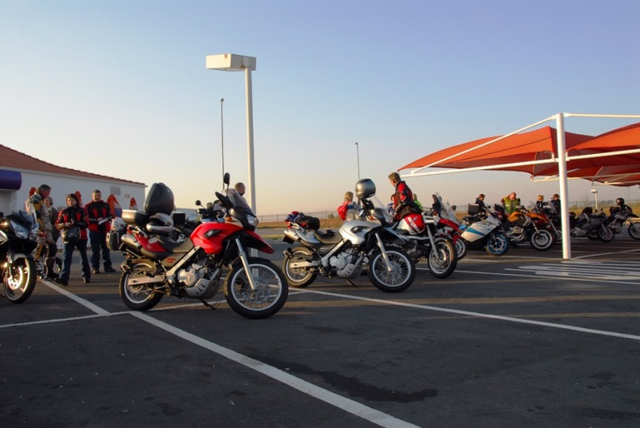
Klerkskraal dam (near Ventersdorp)
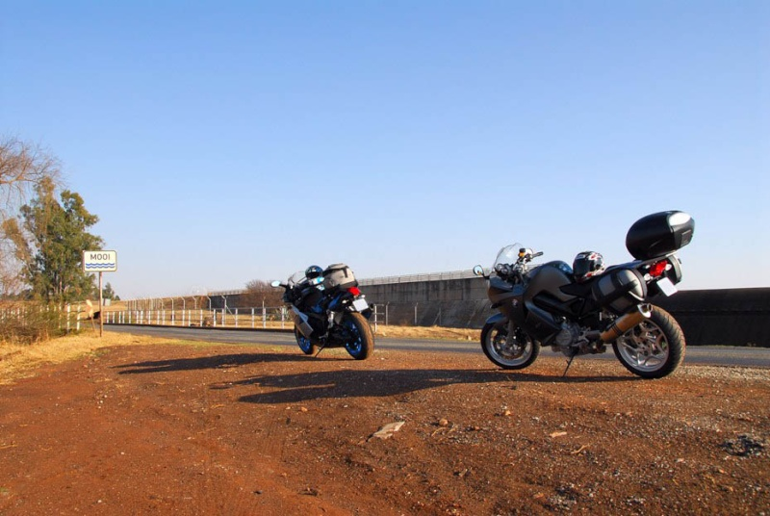
Coligny
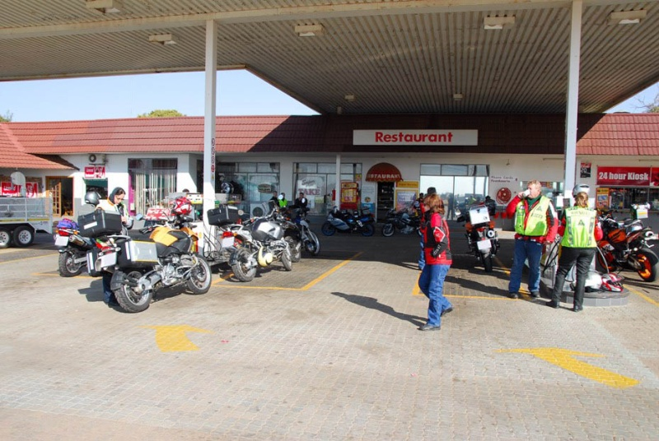
Biesiesvlei
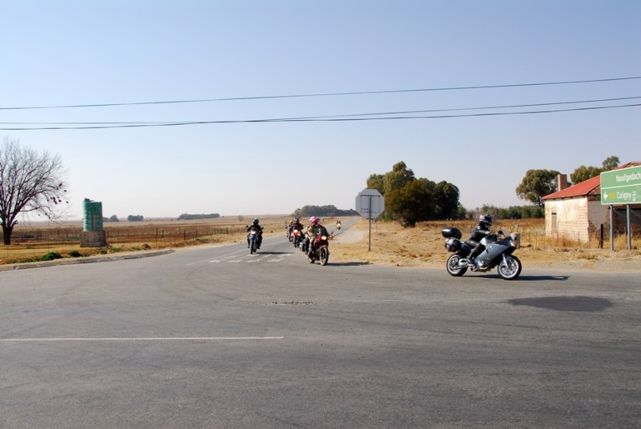
Sannieshof
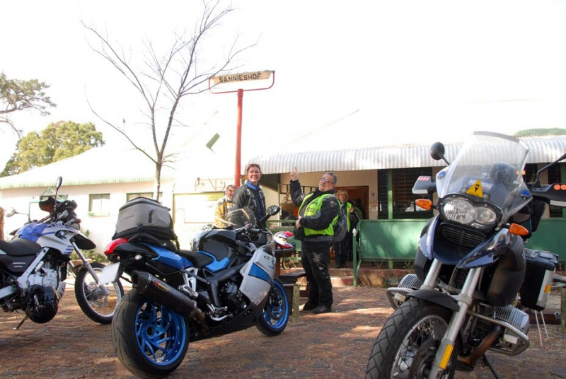
Delareyville (sorry no picture)
Schweizer-Reneke (sorry no picture)
Amalia
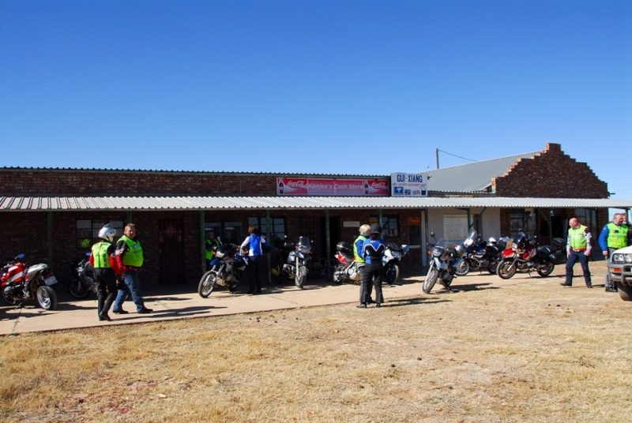
Christiana
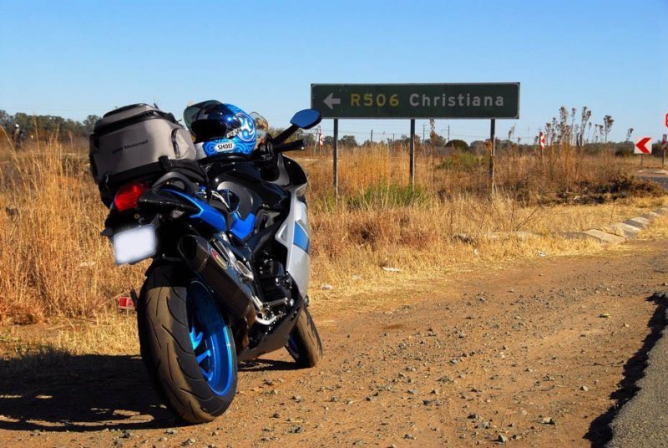
Hertzogville
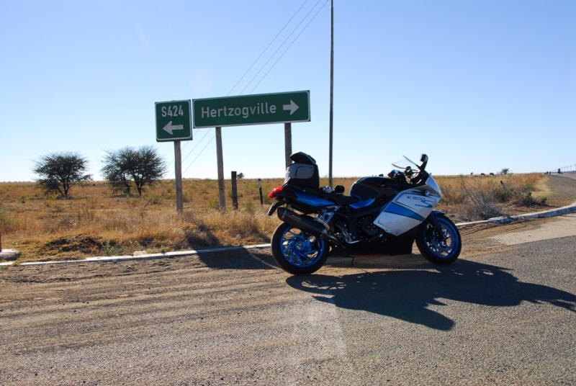
Hoopstad
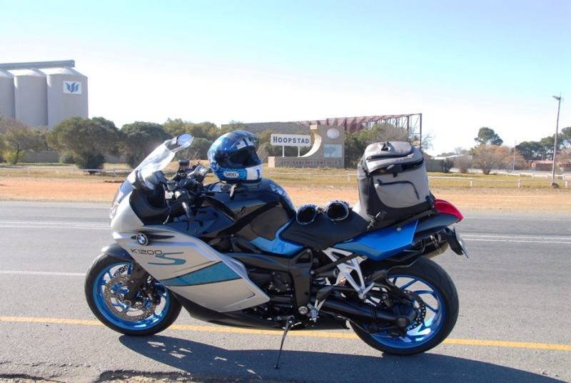
Bothaville (sorry no picture)
Viljoenskroon (sorry no picture)
Parys
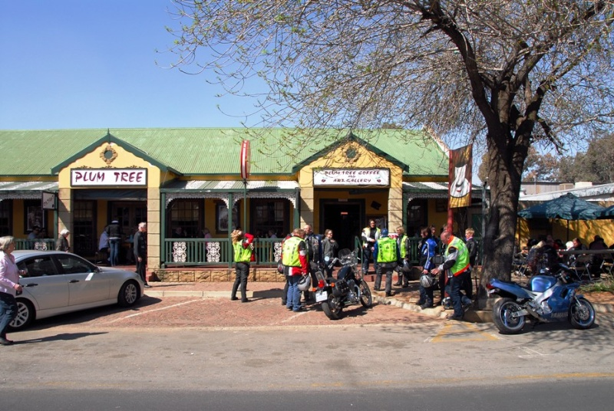
_________________
Let's go forward........the road is calling anyway
JR
The K-factor

Number of posts: 1164
Location: Gauteng
My bike: K1300S, F800GS
Registration date: 2008-06-02

Re: Ladies Ride - Great trip!
by JR on 11th August 2008, 14:07
methinks the ladies deserve special recognition.......therefore the individual faces of the ladies who made the trip (in no particular order)………not sure if they would approve if a name was put to the face, so it was left out.
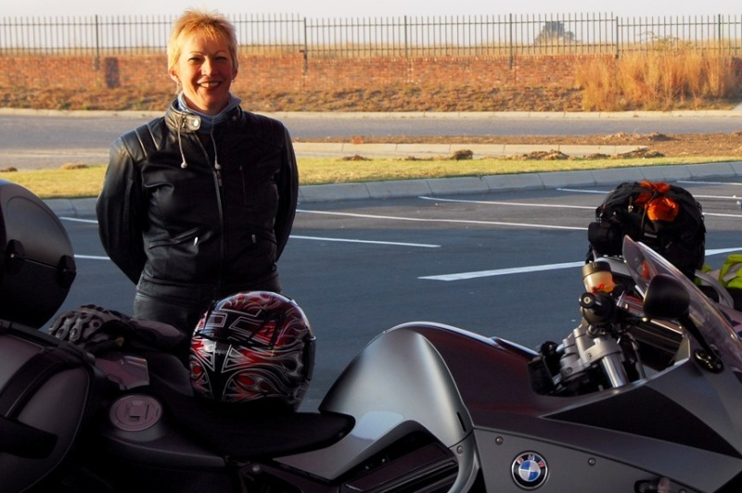
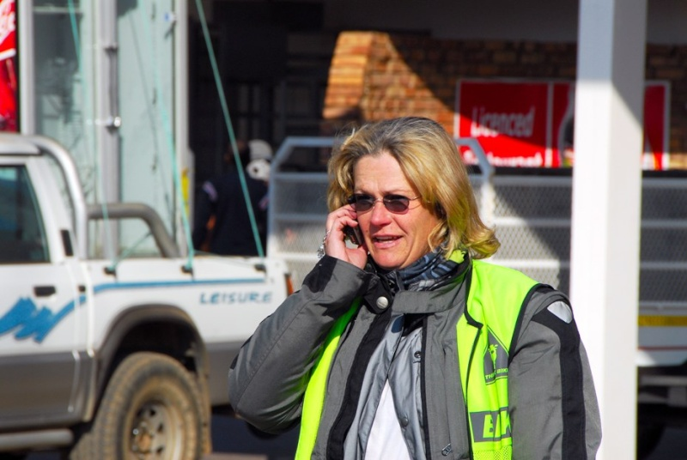
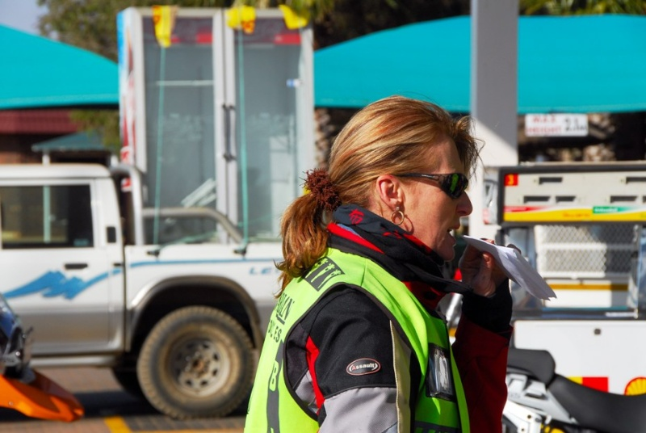
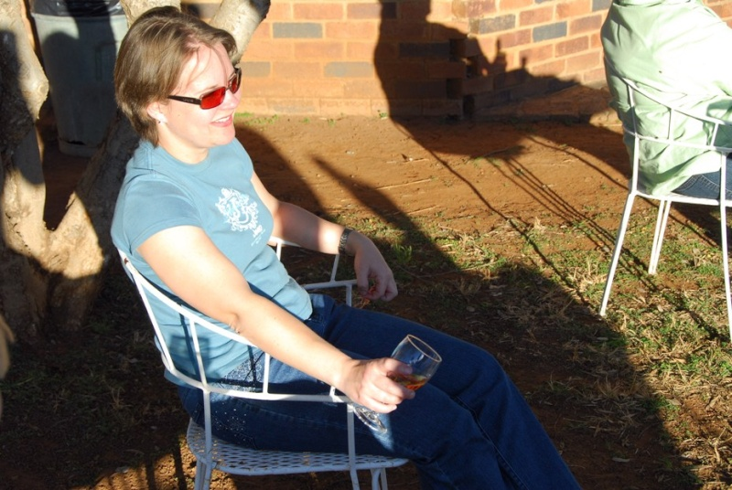
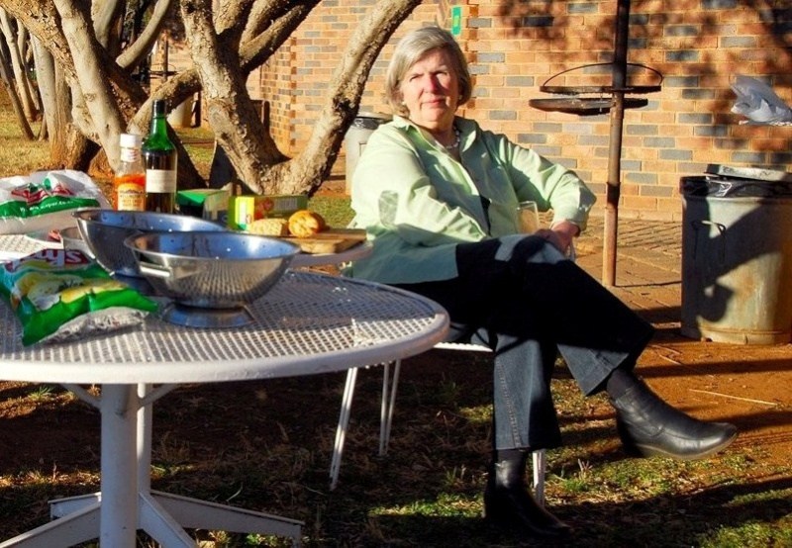
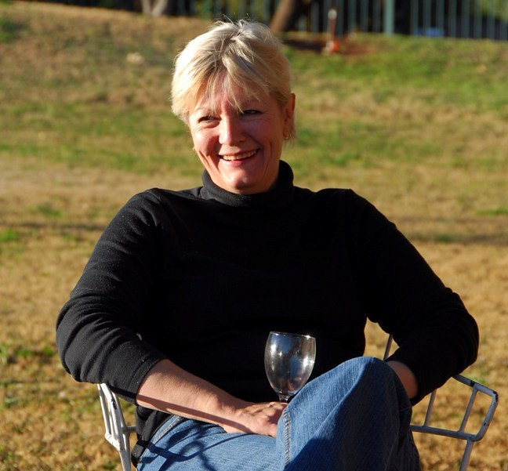
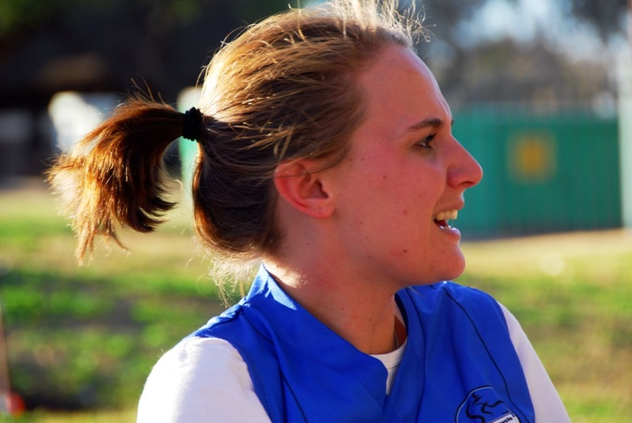
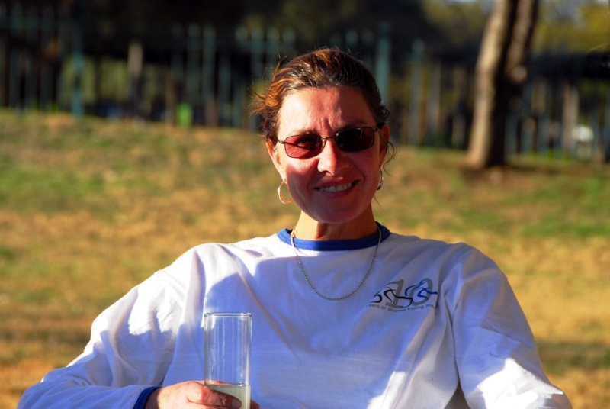
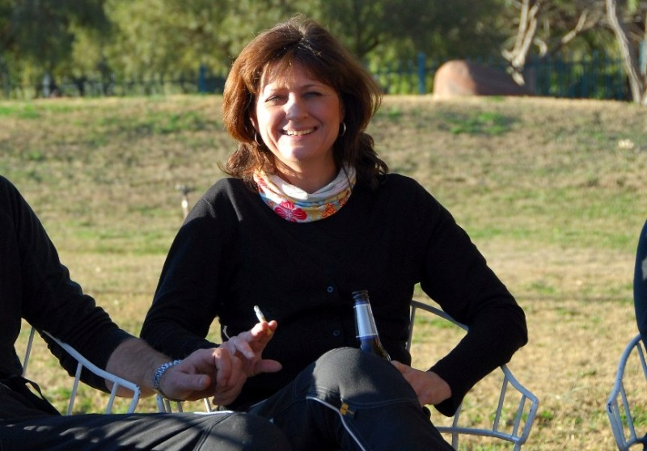
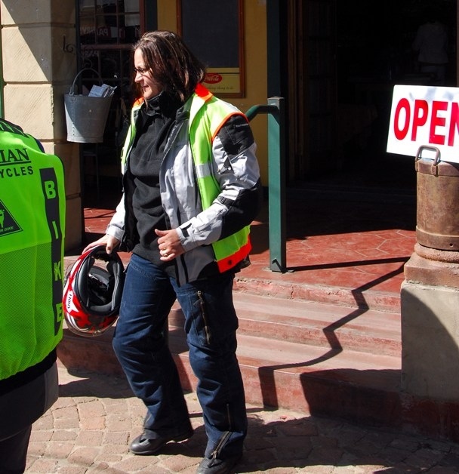
Last edited by MadnohB on 11th August 2008, 15:29; edited 4 times in total
_________________
Let's go forward........the road is calling anyway
JR
The K-factor

Number of posts: 1164
Location: Gauteng
My bike: K1300S, F800GS
Registration date: 2008-06-02

Re: Ladies Ride - Great trip!
by GSlady on 11th August 2008, 14:27
To the ladies of the open road... and the men with their BIG BIKES... thanks for the opportunity to do what we love so much!
Special thanks to Trudie for all the arrangements and for taking the lead - and to Dorothy for checking our backs!
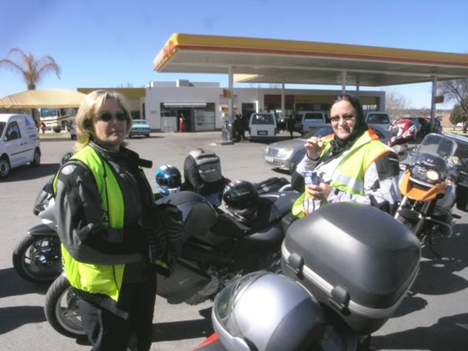
Well done Maureen - a new member to the Club and new to riding - but after the weekend's 1000kms, she's part of the 'family'!
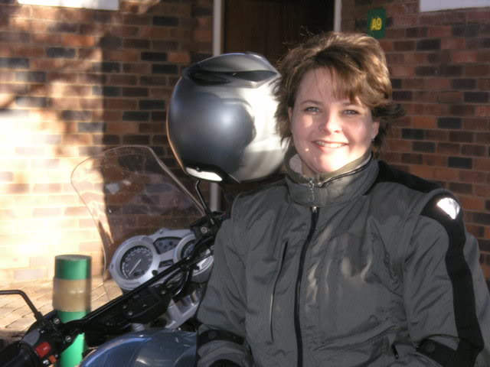
And of course also a Thanks to the photographer!
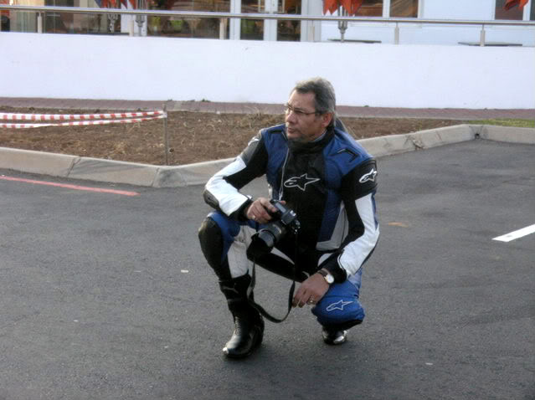
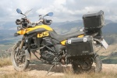
GSlady
Senior Contributor

Number of posts: 799
Age: 49
Location: Pretoria
My bike: 800GS - now with MUCH more character! Still enjoying every minute!
Registration date: 2008-02-29

Re: Ladies Ride - Great trip!
by Corlia on 11th August 2008, 15:18
The weekend trip was a great success! Thank you to anybody and everybody who contributed to making it such a special event! Hopefully next year I will do this trip sitting on my own bike!
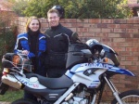
Corlia
Committee member

Number of posts: 285
Age: 26
Location: Meyerspark
My bike: Dakar 650 GS Pillion
Registration date: 2008-07-15

Re: Ladies Ride - Great trip!
by tj on 11th August 2008, 16:30
Corlia wrote: Hopefully next year I will do this trip sitting on my own bike!
That will be funtastic!!
tj
Senior Contributor

Number of posts: 646
Age: 55
Location: Bapsfontein Area
My bike: K1300GT
Registration date: 2008-06-02

Re: Ladies Ride - Great trip!
by Mermaid on 11th August 2008, 18:46
Dani wrote
BMW wrote:To the ladies of the open road... and the men with their BIG BIKES... thanks for the opportunity to do what we love so much!
Special thanks to Trudie for all the arrangements and for taking the lead - and to Dorothy for checking our backs!
And to all the others, thanks for your company. It was a trip to remember for a long time, ...for various reasons. I won't elaborate as what happens on a trip, stays on the trip. For those dying of curiosity, make sure to join the trip next year!
_________________
Too sexy for my Bike !
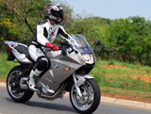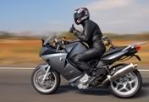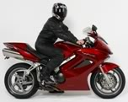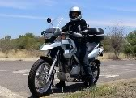
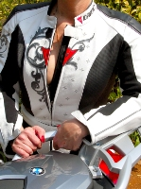
Mermaid
Fuel Injected

Number of posts: 23
Location: Centurion
My bike: F800ST K9
Registration date: 2008-06-05

Re: Ladies Ride - Great trip!
by JR on 11th August 2008, 19:03
ping BMW (Admin) & Sias........you have a pm
_________________
Let's go forward........the road is calling anyway
JR
The K-factor

Number of posts: 1164
Location: Gauteng
My bike: K1300S, F800GS
Registration date: 2008-06-02

Re: Ladies Ride - Great trip!
by DeonP on 11th August 2008, 19:30
Wow.Looks like I missed a good one.
Thanks for all the pics - always great to see.
Well done, looks like it was a great success !
Dorothy, please don't get too comfortable as sweep. I know you like the speed up front as well !
Well done to all !
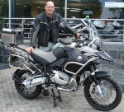
DeonP
Turbocharged

Number of posts: 402
Location: RANDPARK RIDGE , GAUTENG
My bike: 1200GS ADVENTURE
Registration date: 2008-07-09

Re: Ladies Ride - Great trip!
by Big Blue on 12th August 2008, 10:43
Morning Everyone
Thanks to all the ladies who made the ride what it was - I think Trudi deserves a special mention but also Dorothy for sweeping and Isolde for driving the back up vehicle. Kudo's to Maureen who was riding (and leading) with much more confidence by Sunday. I think a three day trip is in order next year. Thanks also to everyone who took such great photo's.
And for Trudi's sake , what goes on tour will stay on tour!
D
Big Blue
Committee member

