Re: Stokkiesdraai - report
by tj on 9th March 2009, 07:54
The event was joined by 24 souls & (I think) 18 bikes. The pontoon ride was wonderful and looked if everybody enjoyed it. The breakfast was good and well prepared albeit at the beginning not enough for all the hungry tummies - but soon was the bowels stocked up when the rubberduck moored alongside the pontoon.
The ride to Stokkies was calm and law-abiding. An Audi R8 (without numberplates) was pulled off for speeding on the R59 while we just sailed through beautifully...
...Untill we pulled away from the turn at Vredefort Dome; When we stopped at the turnoff at Viljoenskroon Cobus (visitor and friend on a Blackbird) and I mentioned both we are going to wait some time for the others, but then they started catching up about 10 seconds later! Dave said somebody must've detuned his bike and AB longs for his previous. Wonder why? All were referring to GPS speeds, etc. I had nothing to complain!
Even little Maureen on her new ST was quick on the spot.
Gemmerkat obviously was on the roll again with the excuse of 'having to take pictures'
This can easily be done again! I hope!
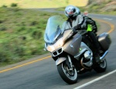
tj
Senior Contributor

Re: Stokkiesdraai - report
by DaveS on 9th March 2009, 13:32
tj wrote:
Gemmerkat obviously was on the roll again with the excuse of 'having to take pictures'
Thanks for a great trip.
Must be something wrong with my computer because I can't see any pictures??
_________________
When I was born I was so surprised I didn't talk for a year and a half!
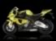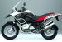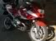
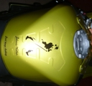
DaveS
Committee member

Re: Stokkiesdraai - report
by Tony R on 9th March 2009, 16:12
Mine too.
Tony R
Turbocharged

Re: Stokkiesdraai - report
by Chris on 9th March 2009, 16:26
Great trip… thank you. What a lovely day. Waiting for the evidence
_________________
Don’t run with scissors…
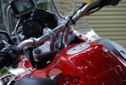
Chris
Supercharged

Re: Stokkiesdraai - report
by Mud Pooh-bah on 9th March 2009, 16:51
Glad to see the lovers of tar came from hiding eventually. Now please stop being shy and show us GSers that you can operate those cameras!!!!
_________________
Catapultam habeo. Nisi pecuniam omnem mihi dabis, ad caput tuum saxum immane mittam.
Peritissimos semper praevidere possumus, rudi autem periculosi sunt.
Vah! Denuone Latine loquebar? Me ineptum. Interdum odo elabitur.
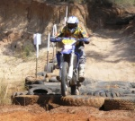
Mud Pooh-bah
Turbocharged

Re: Stokkiesdraai - report
by Admin on 9th March 2009, 16:54
Watch this space..
As a 'maplotter', Gemmerkat's internet connection doesn't allow uploading of images .. but the promise has been made to give Admin the stick/CD/camera ..
Admin
Admin

Re: Stokkiesdraai - report
by Marnus on 9th March 2009, 17:01
Admin wrote:but the promise has been made to give Admin the stick
Can we also have a picture of that??? 
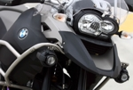
Marnus
Committee member

Re: Stokkiesdraai - report
by szalek on 10th March 2009, 18:18
Hmmm Sorry I missed the ride.Sound it was fun. Now we are all waiting for the photos.
szalek
Supercharged

Re: Stokkiesdraai - report
by DaveS on 10th March 2009, 21:21
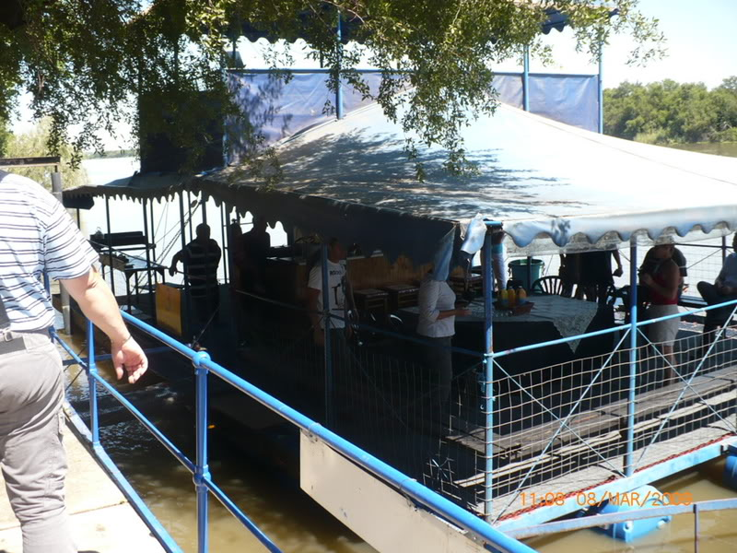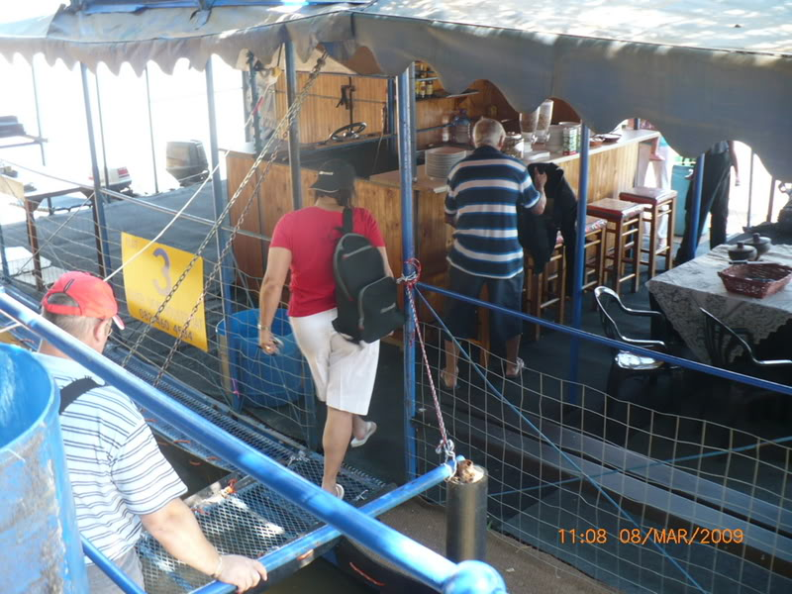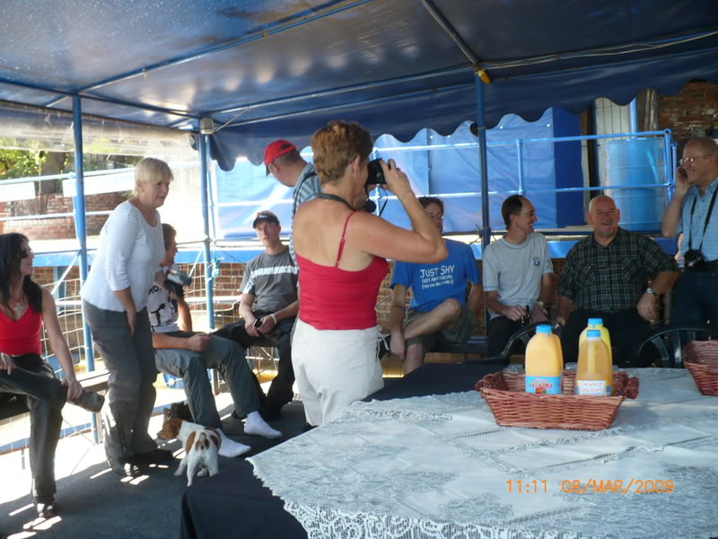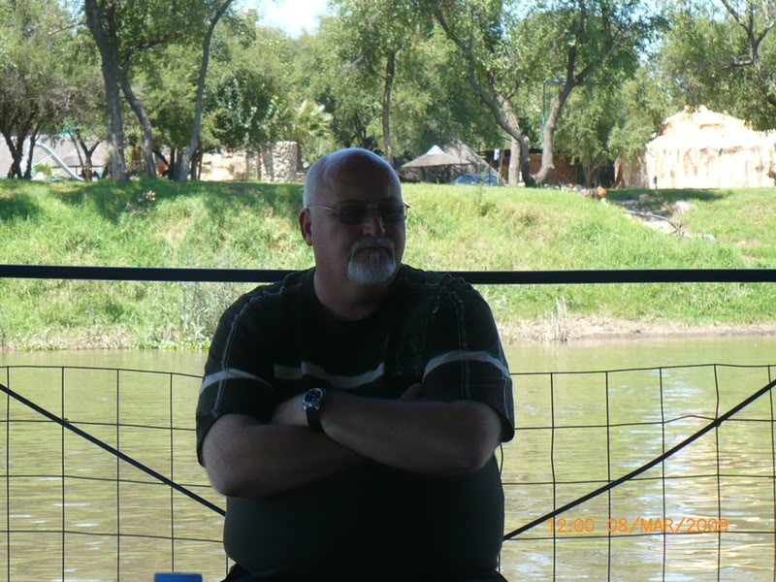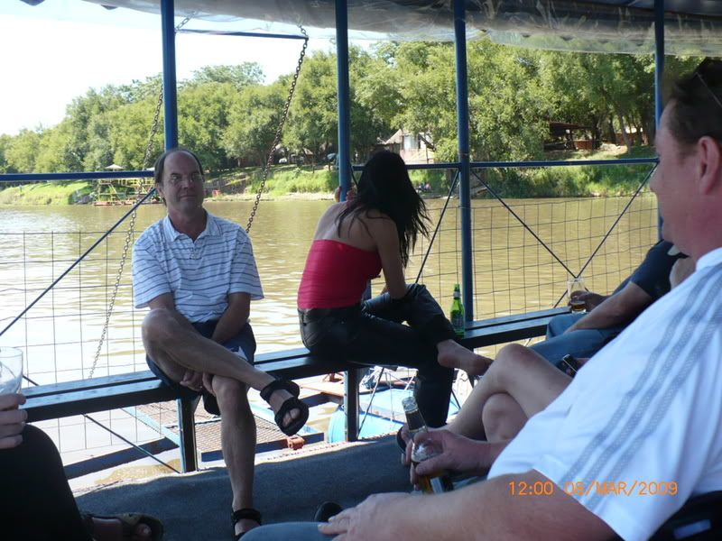
_________________
When I was born I was so surprised I didn't talk for a year and a half!
DaveS
Committee member

Re: Stokkiesdraai - report
by Corlia on 11th March 2009, 13:48
Looks as though you guys enjoyed it! Seems like a nice relaxing Sunday afternoon cruise on the river!! Thanks for sharing!
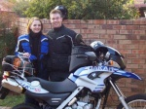
Corlia
Committee member

Re: Stokkiesdraai - report
by Admin on 11th March 2009, 20:41
Marnus wrote:
Admin wrote:but the promise has been made to give Admin the stick
Can we also have a picture of that???
one has to watch your words here...
Admin wrote:but the promise has been made to give Admin the flash disk
fixed?
Gemmerkat and tj's pictures will be transferred and uploaded tomorrow
Admin

Give me the stick
by Admin on 12th March 2009, 15:36
It was a blue stick...
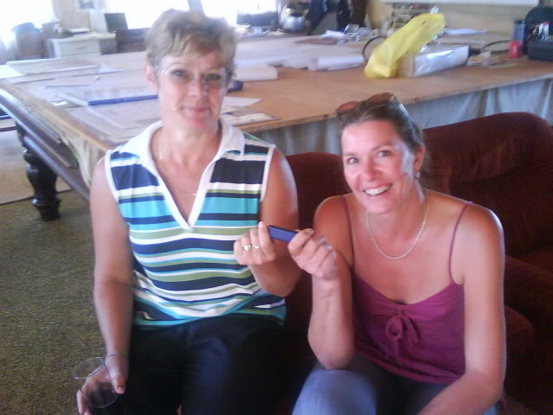
Watch this space...
Admin
Admin

Re: Stokkiesdraai - report
by Admin on 12th March 2009, 15:48
On behalf of Trudie...
I need help with captions??
1.
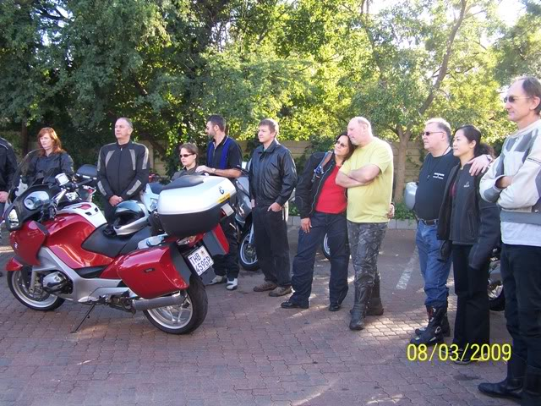
2.
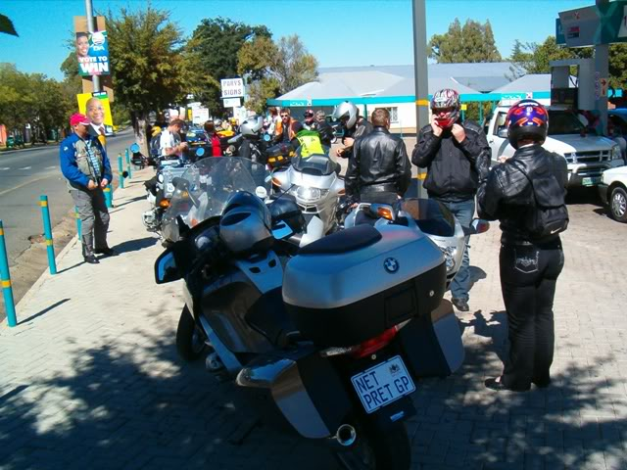
3.
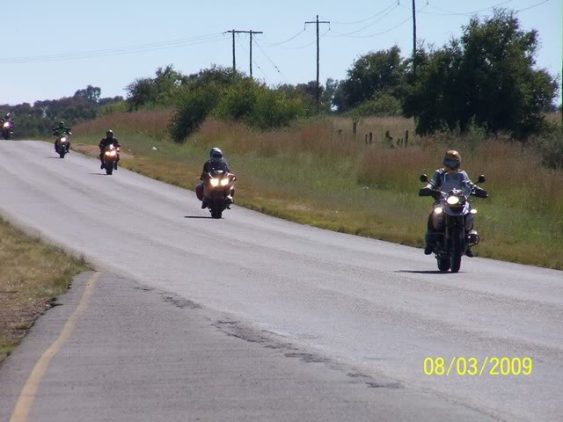
4.
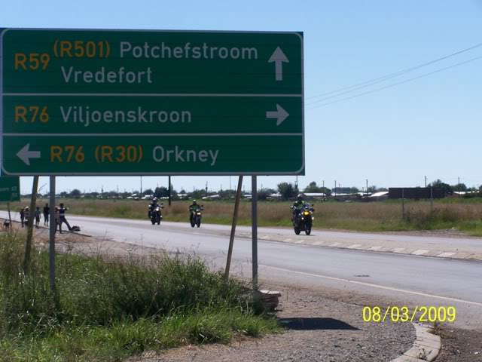
5.
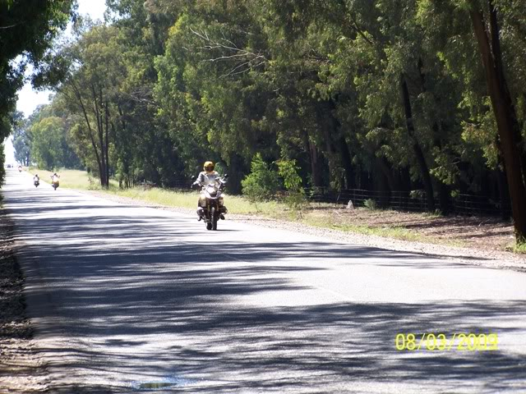
6.
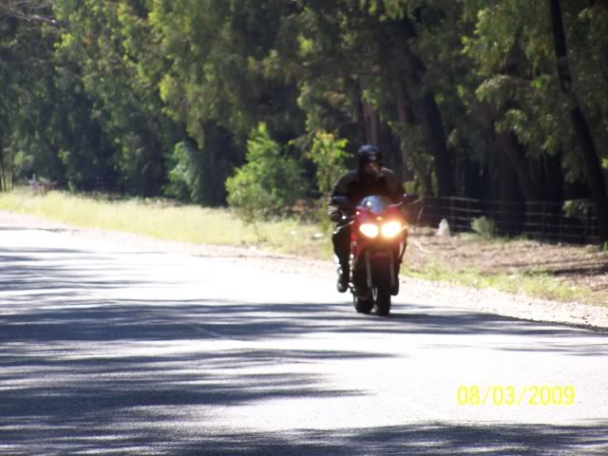
7.
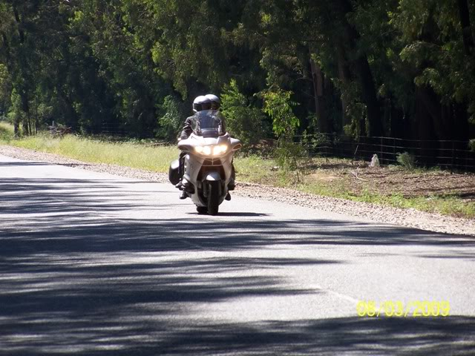
8.
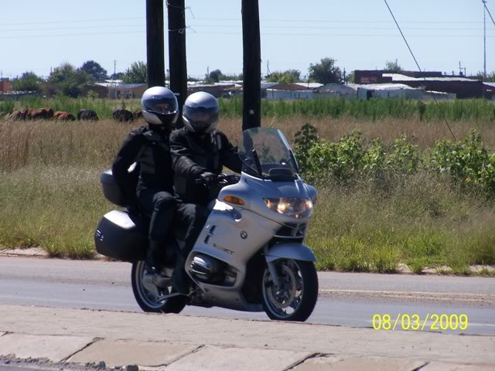
9.
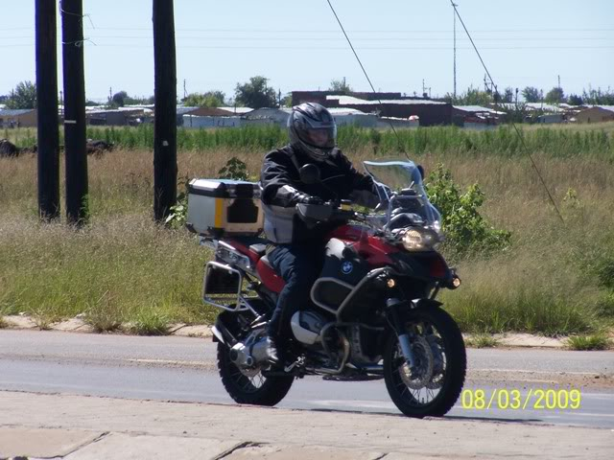
10.
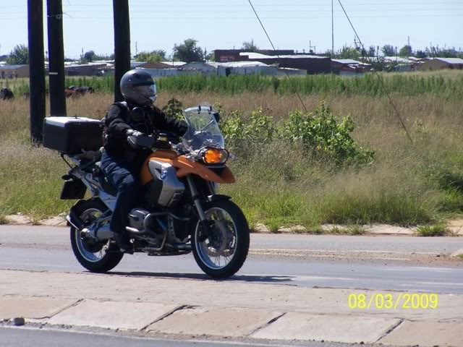
11.
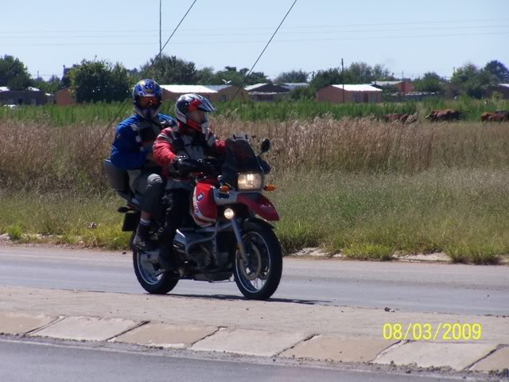
Last edited by Admin on 12th March 2009, 17:28; edited 2 times in total
Admin

Re: Stokkiesdraai - report
by Admin on 12th March 2009, 15:48
And more..
12.
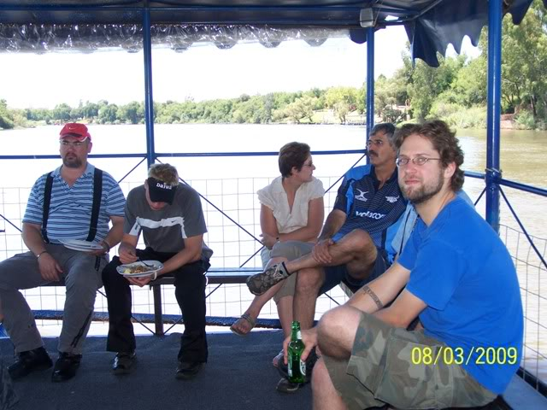
13.
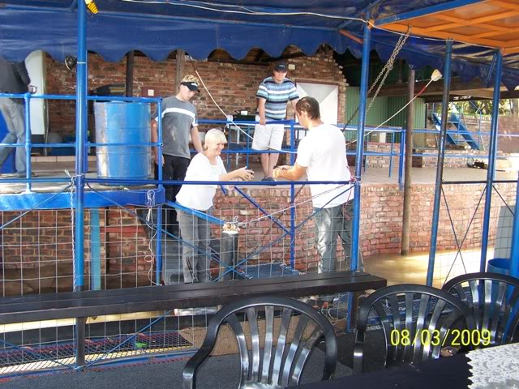
14.
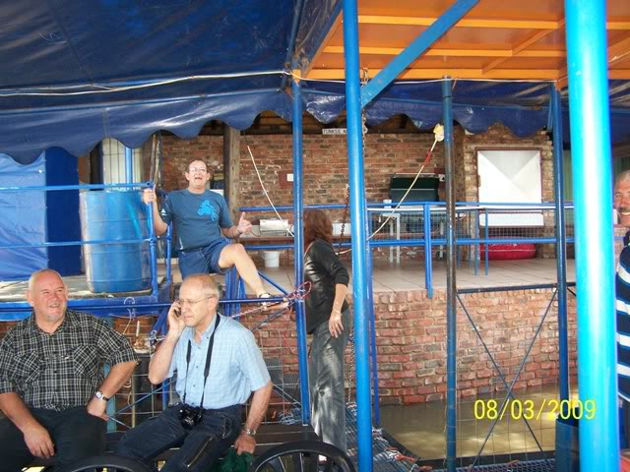
15.
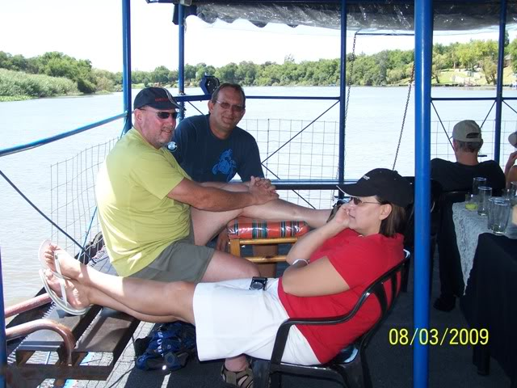
16.
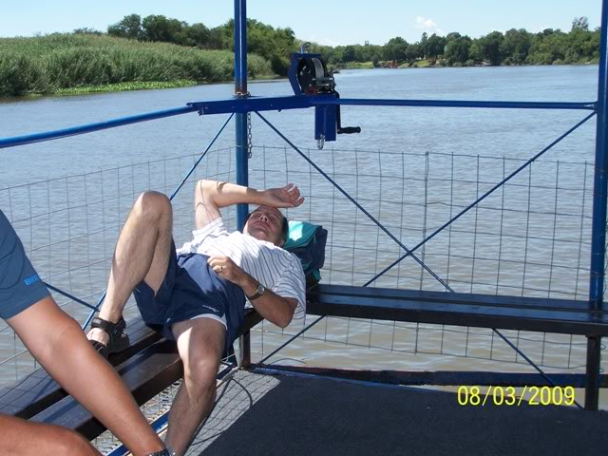
17.
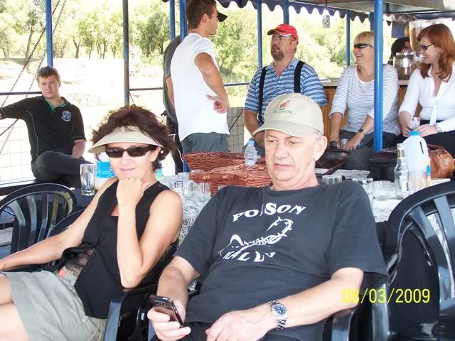
18.
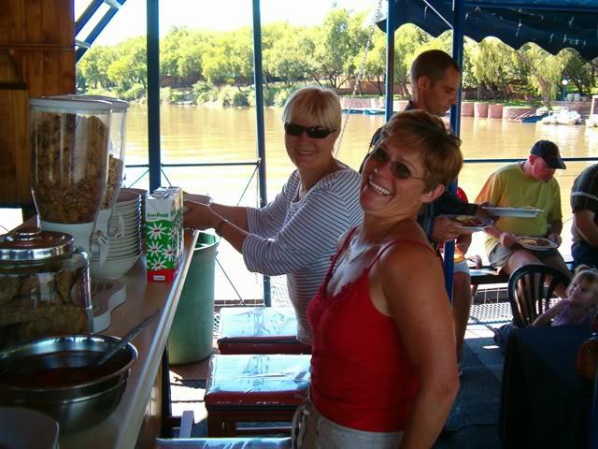
Any comments/captions welcome.
Admin

Re: Stokkiesdraai - report
by Mud Pooh-bah on 12th March 2009, 18:04
At last, proof that we have a road group in our Club.
Mooi fototjies julle!!!
_________________
Catapultam habeo. Nisi pecuniam omnem mihi dabis, ad caput tuum saxum immane mittam.
Peritissimos semper praevidere possumus, rudi autem periculosi sunt.

