Sunday Run - Memorable Buildings
by DeonP on Sun 6 Sep 2009 - 14:47
Thank-you to Johan and Trudie for yet another well organised and executed Sunday Run !
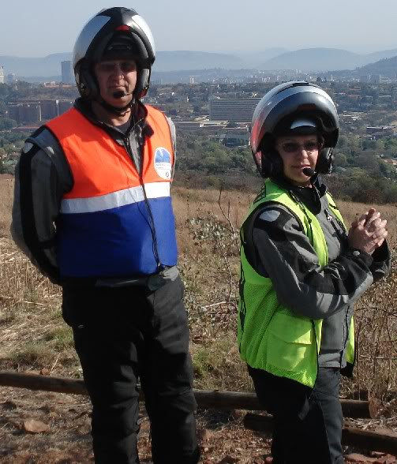
A very good turn out - Summer is here !
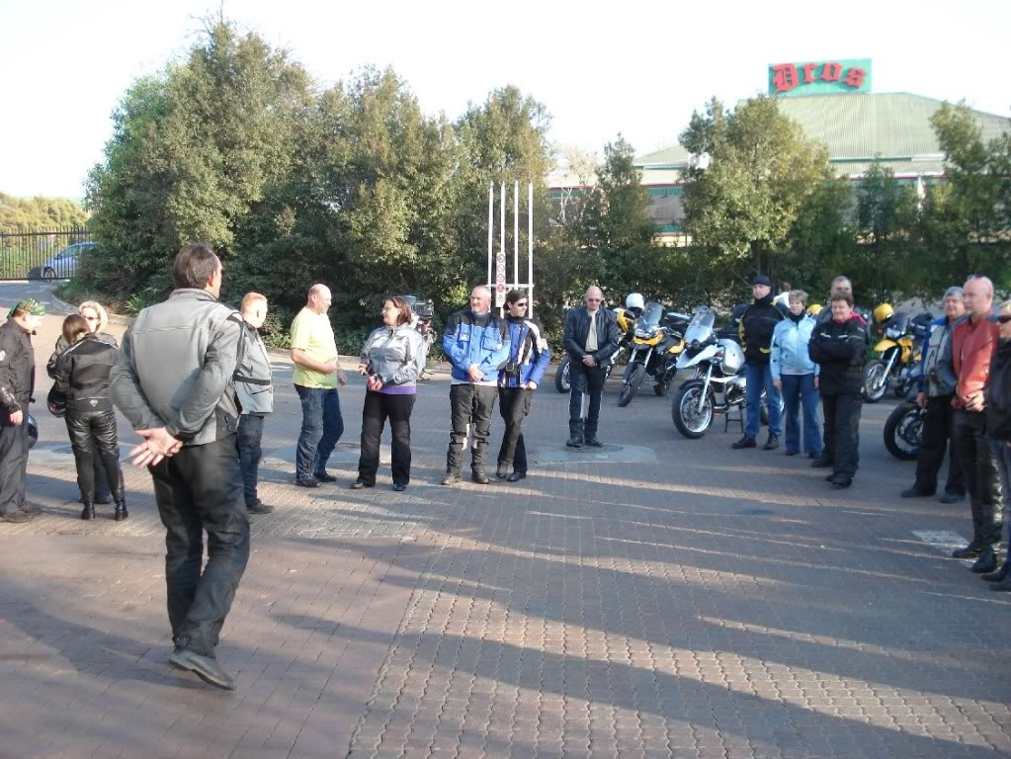
Johan ( during ride briefing) entertaining - as ever !
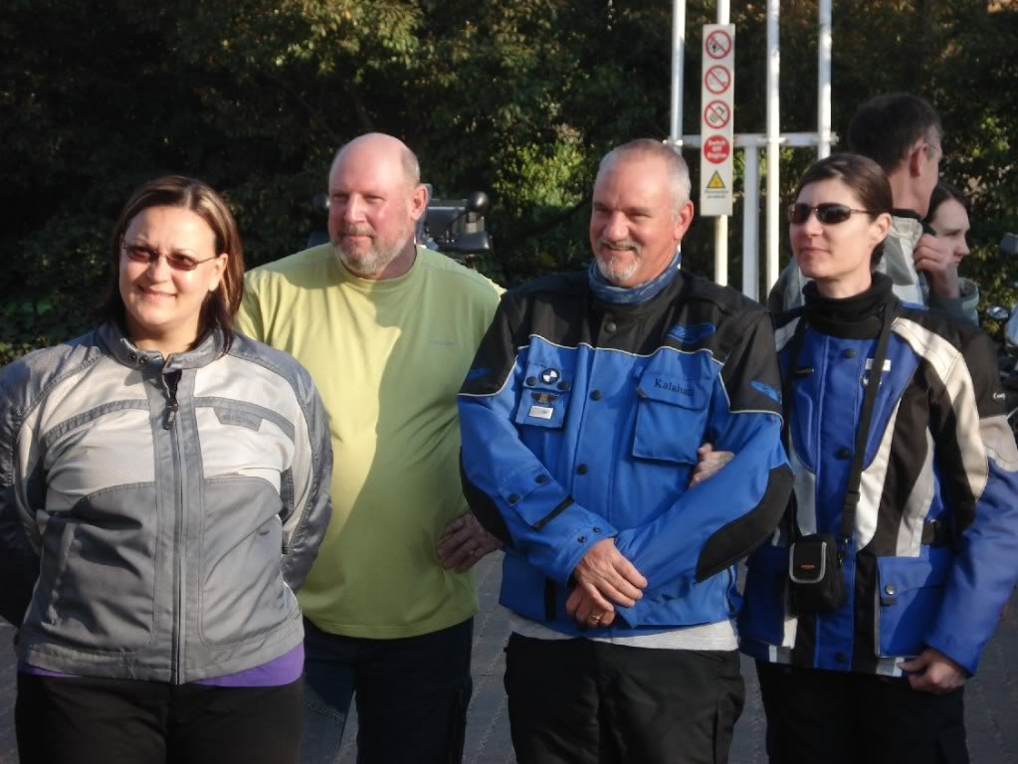
Pretoria BMW club hits Church Square, Pretoria in mass
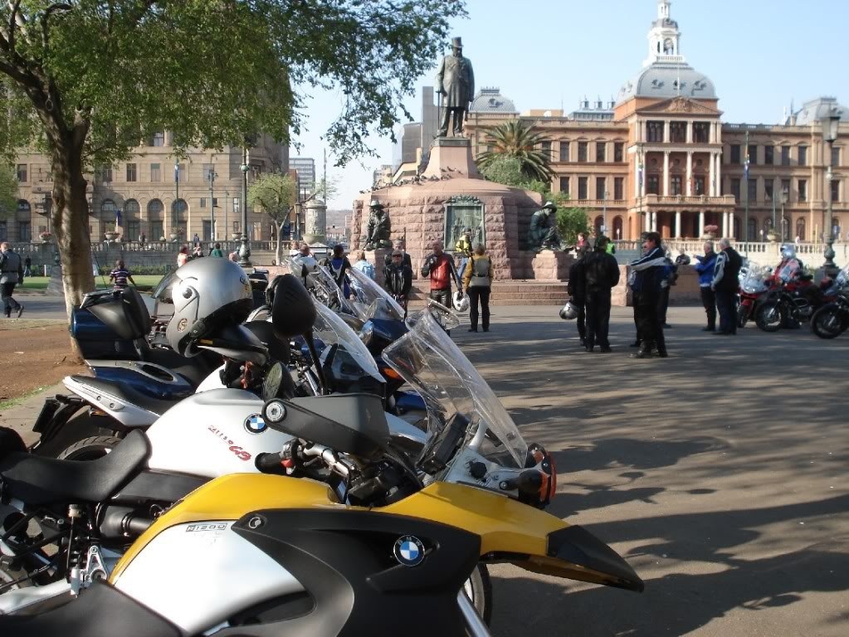
Girl-power out in full force again !
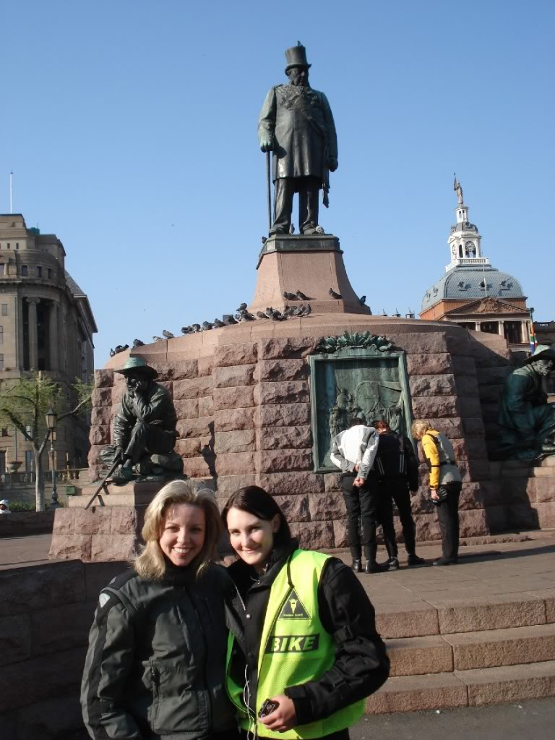
Dave and Dot !
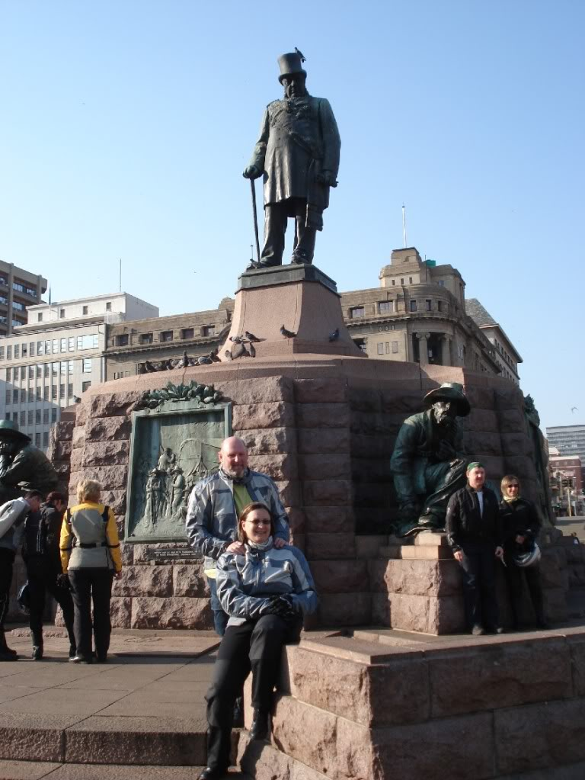On top of the world - near Fort Klapperkop - what a view !
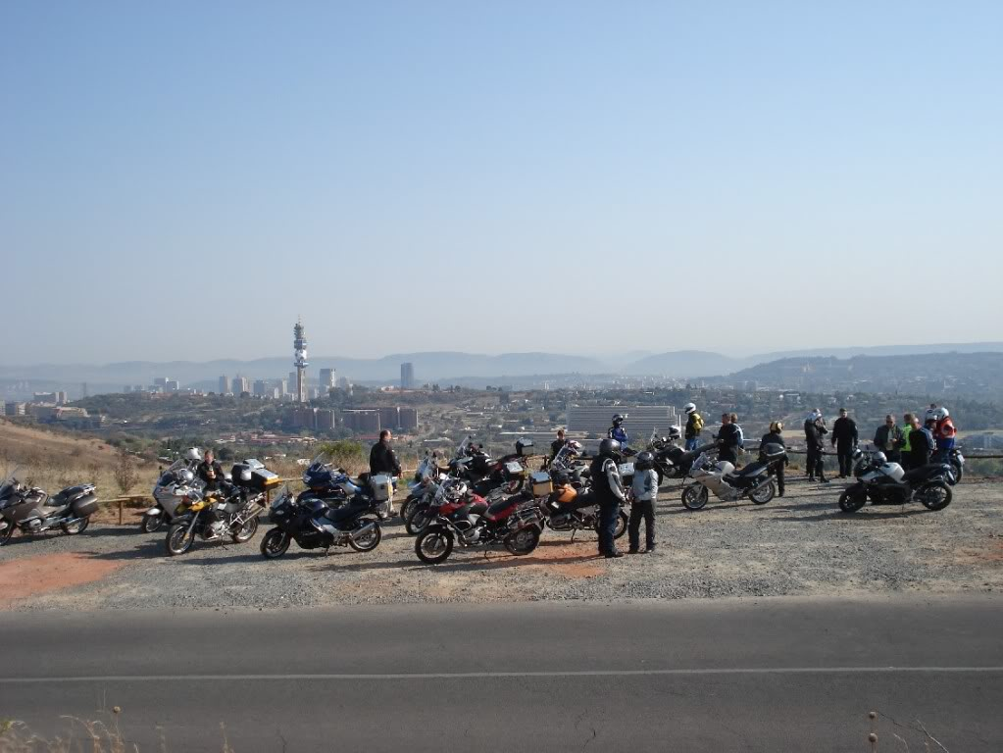
The mass approaching viewpoint
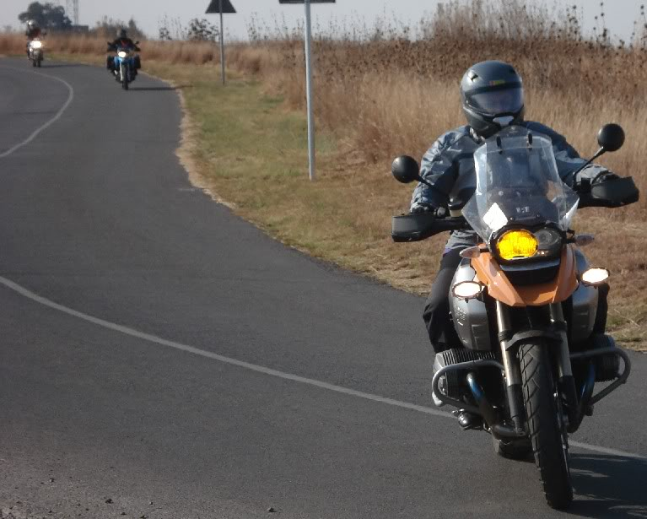
JHB Central - surprizingly clean & seemed safe !
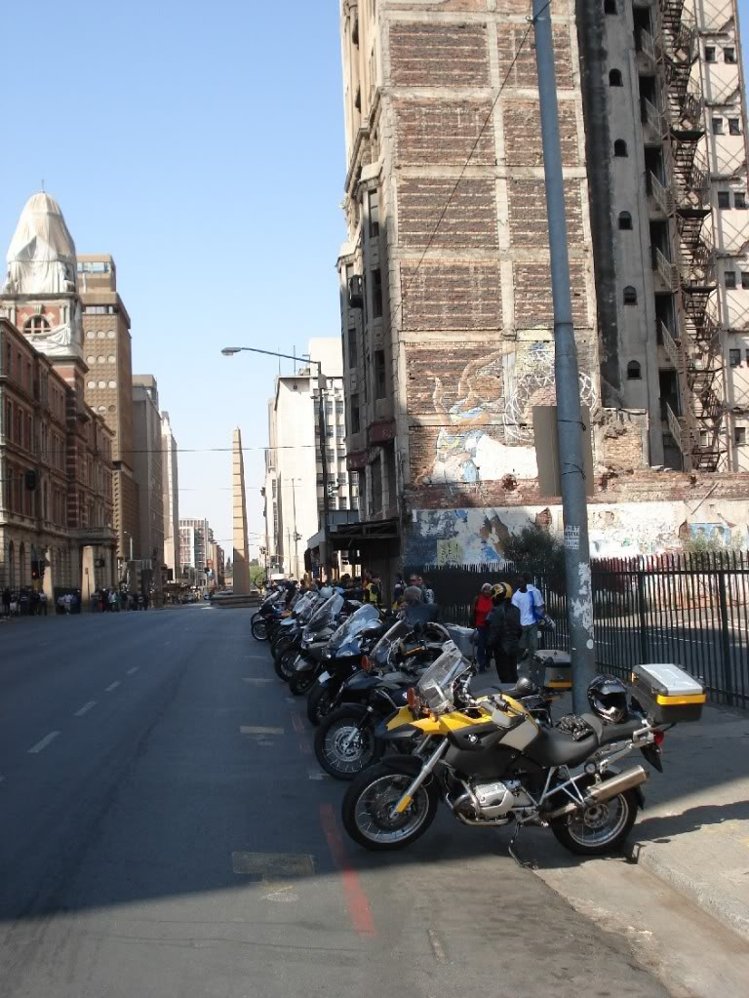
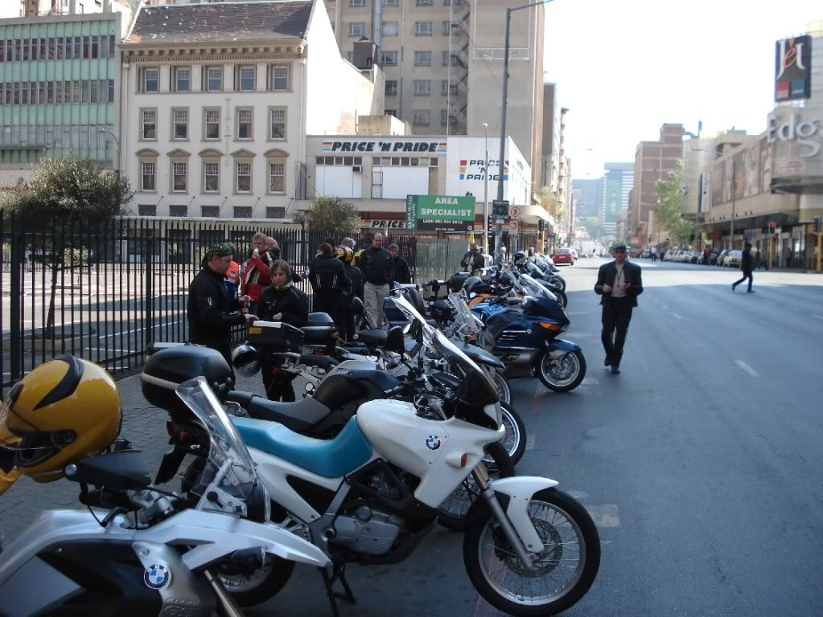
A great end to a great morning - Irene Dairy Farm - Fantastic Breakfast !
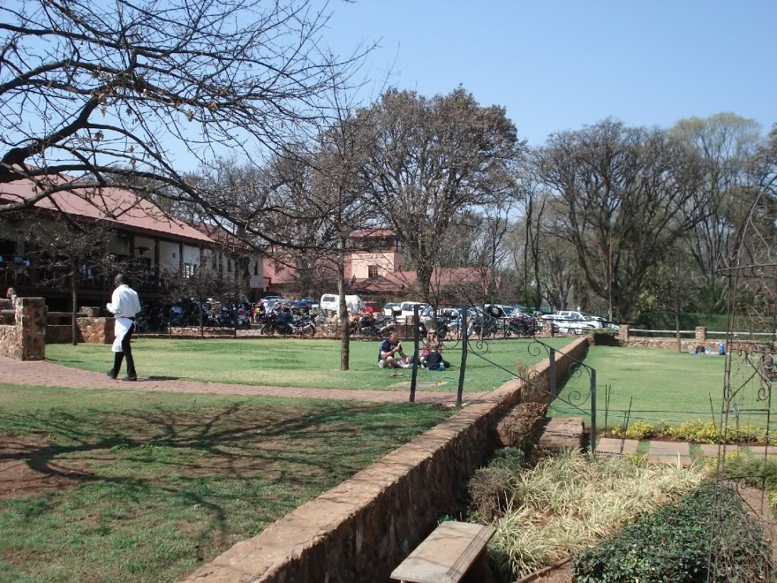
.
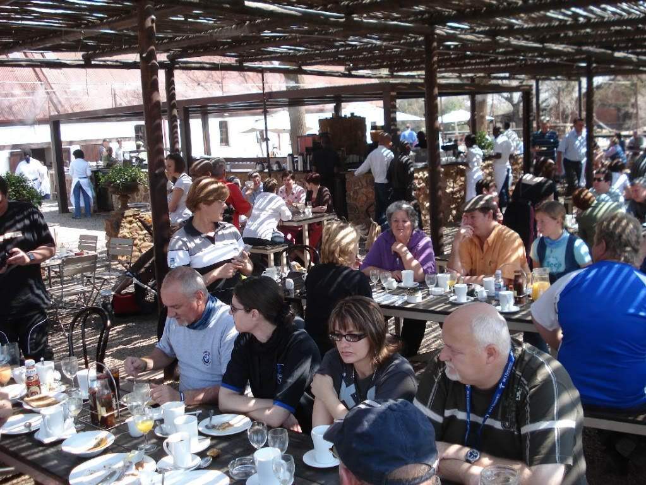
Thanks again to Johan & Trudie and all who attended. A Sunday morning well spent !

