Beestekraal - S's & GS's
by tj on 4th October 2009, 16:09
The morning started with a phone call from Frik at 05h30: " Is the ride still on... due to the rain?" "Ofkors" we replied.
and then a good number pitched at Zambesi Motorrad, in time and tanks filled to the brim!
1. The paving still wet after a good downpour earlier
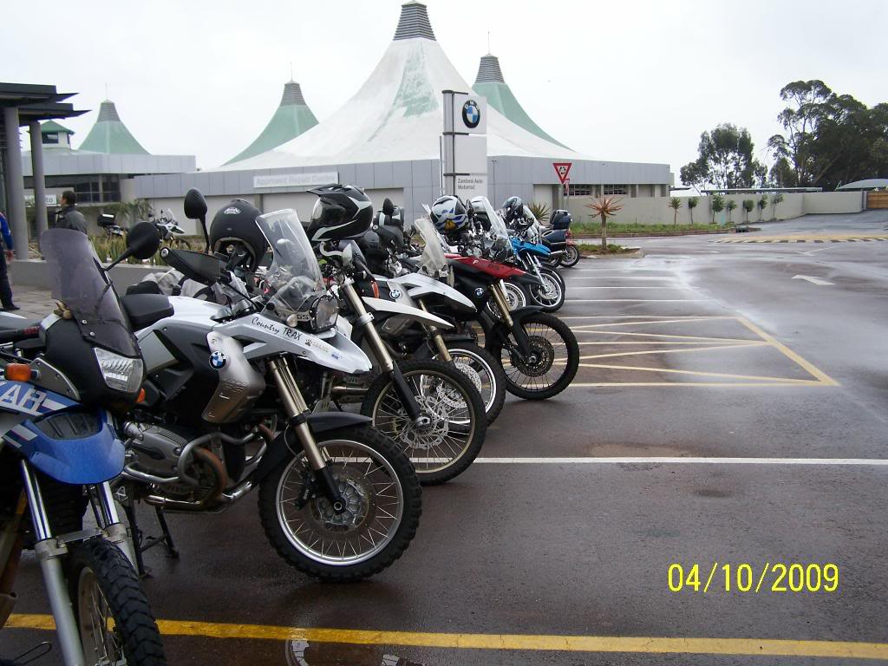
To all those members who were affraid of the rain...
... you missed a lot!
3. Alistair and his staff put up a splendid welcome with filter coffee on the tap and an offer of discounted rider stuff. Thanks Zambesi Motorrad, we enjoyed and appreciate your hospitality
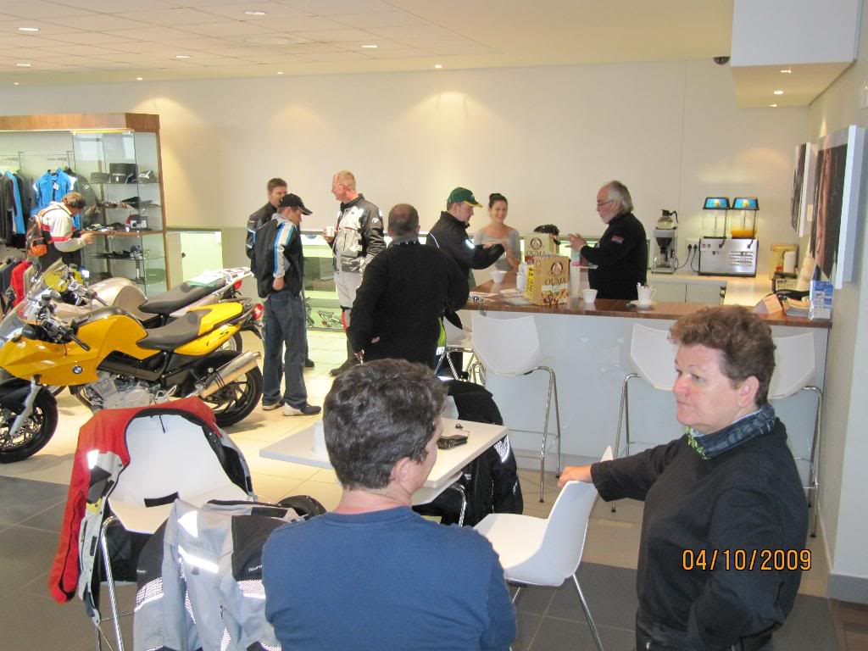
2. JR You have competition in the making! Albeit feet barely touching ground.
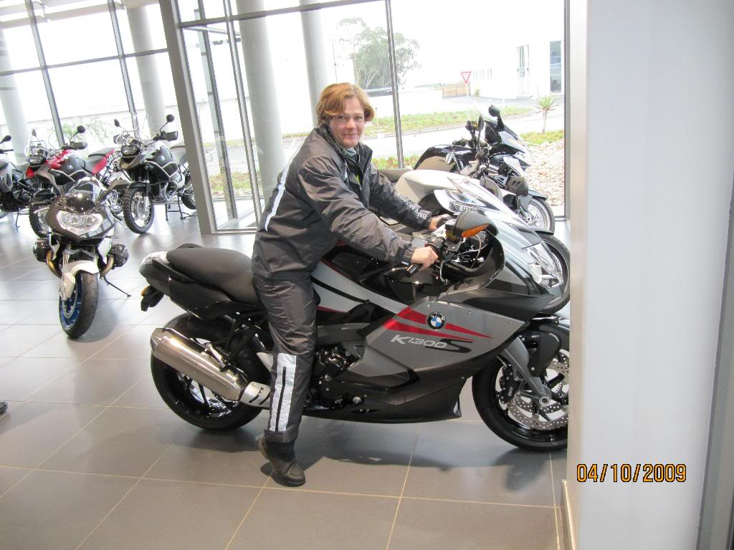
4. At the intersection at Damdoryn. Beautiful pic, Gemmerkat. As usual you did top revs to get into that position, huh?
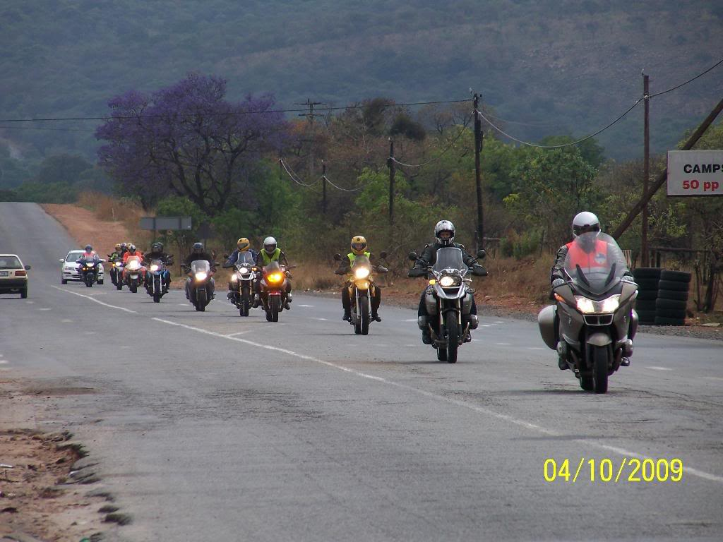
5. The Northam dance: Practice...
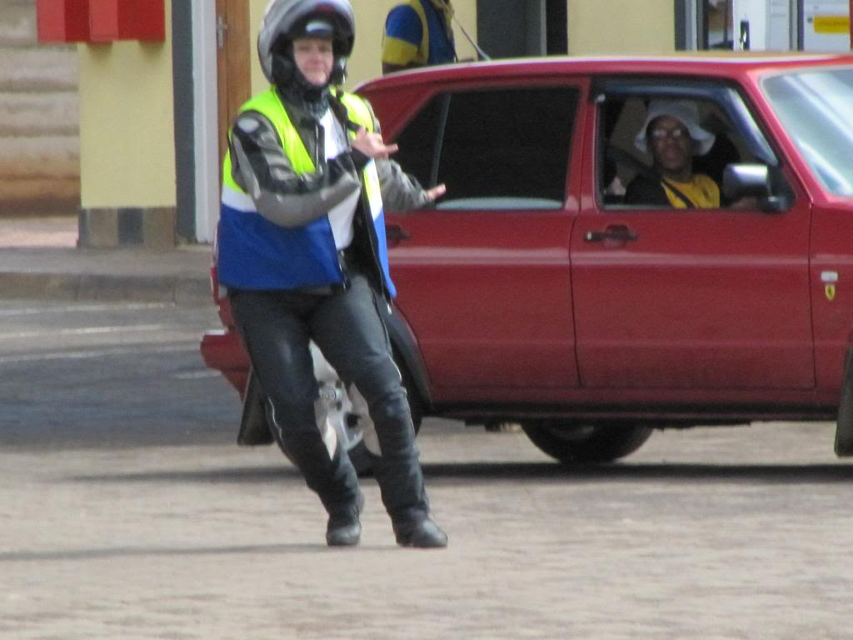
6. A bit better, this one...
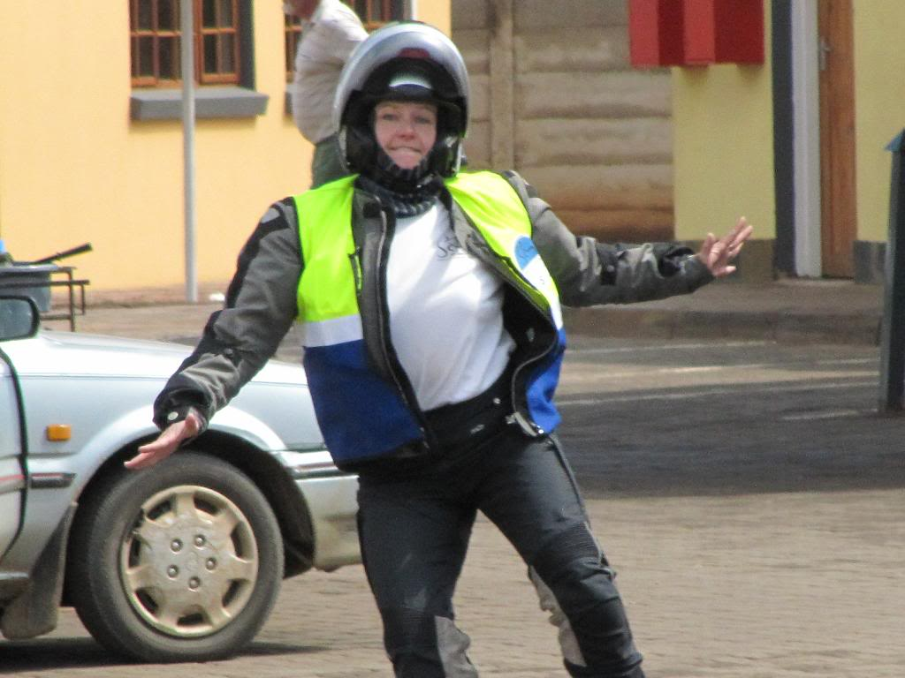
7. Now we're getting there, nearly...
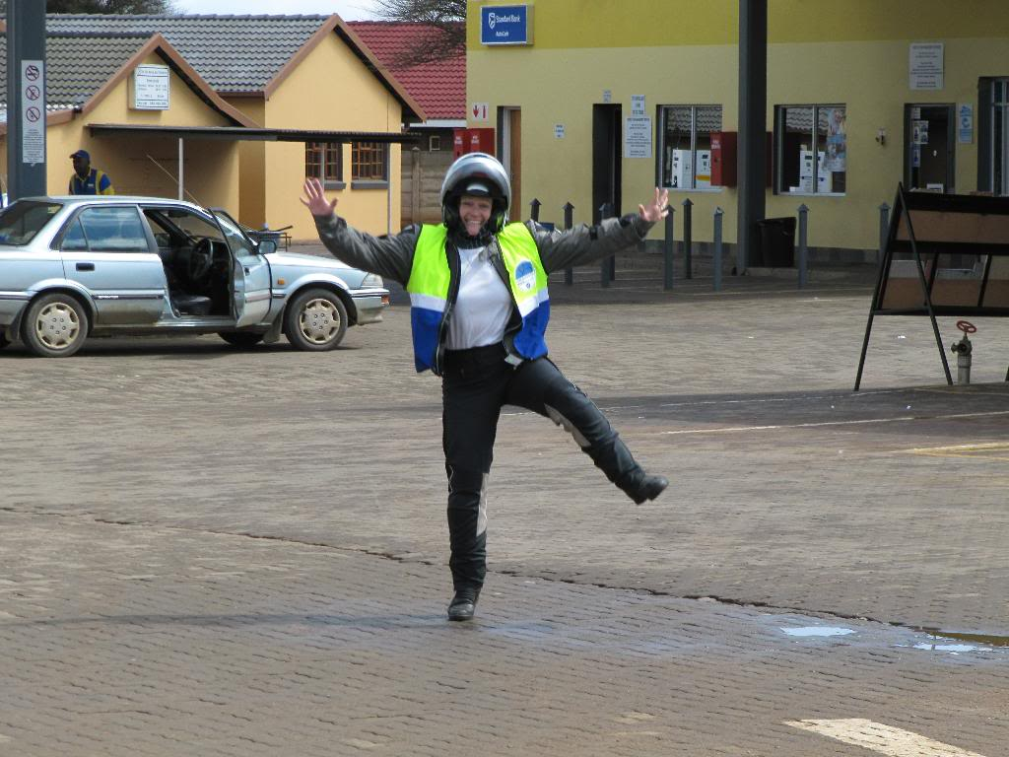
8. A ha. That's it Gemmerkat
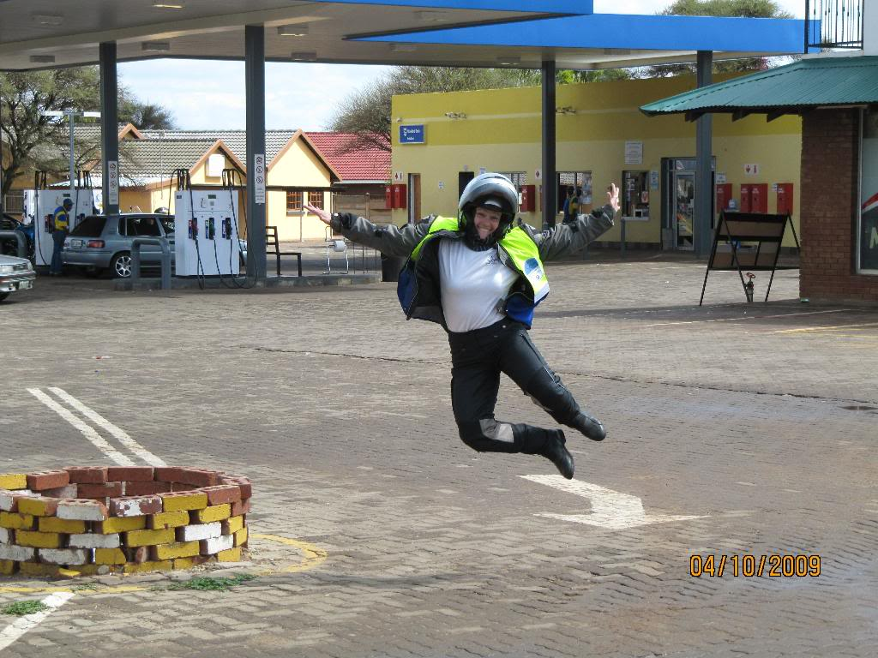
9. Frik also jumping on the 'bandwagon'. Age is showing clearly here... Balance? Poise?
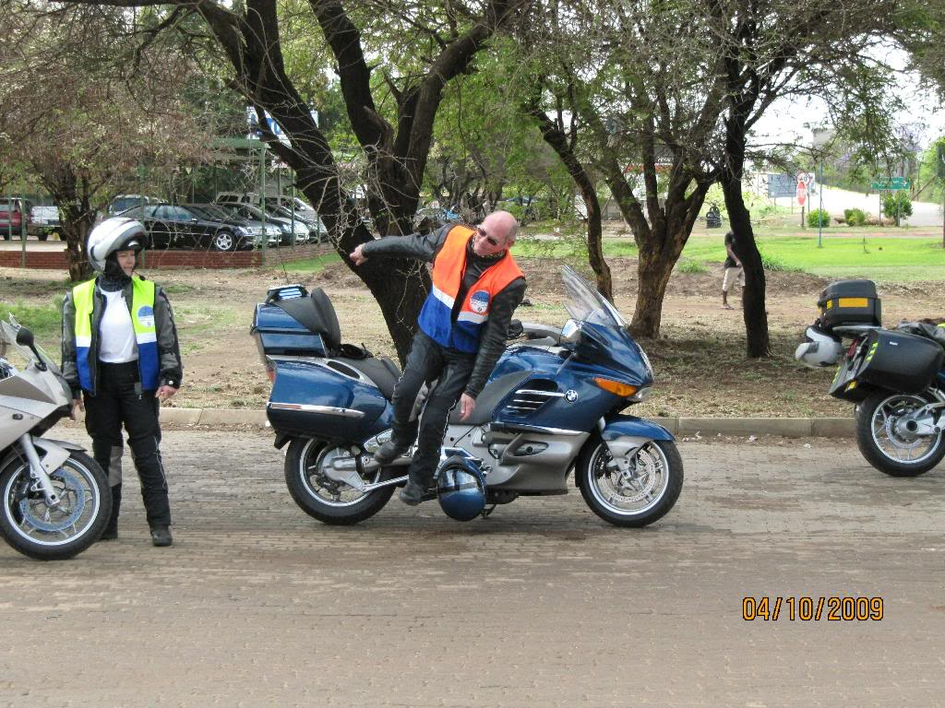
10. Wow Sue! Where did you practise that one? On teasing Abe at home, huh?
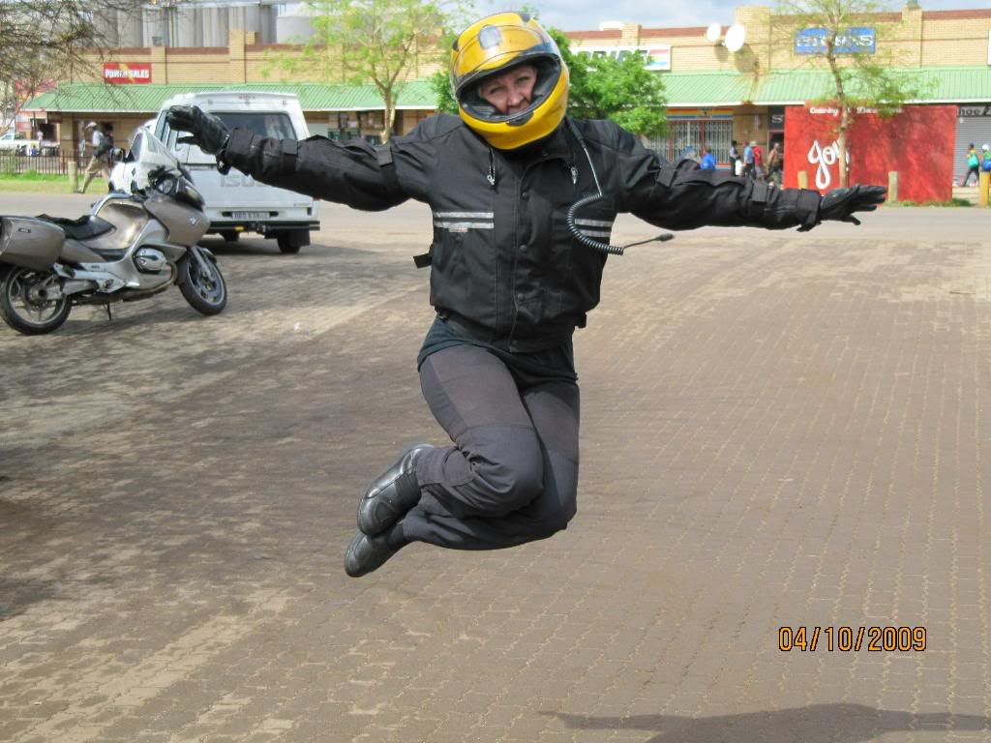
11. No. She wouldn't do the jump. Wie is jy meisie???
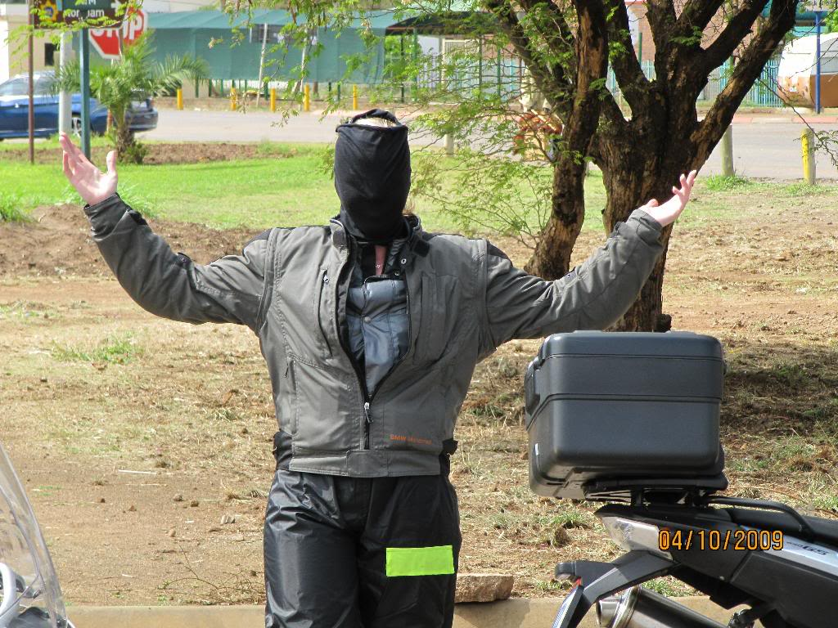
12. Bruno creates an allergic reaction (at will) whenever he touches tar. Shame, poor man. But then it is not so easy on gravel either... Marnus on his left. Siamese twins we have here?
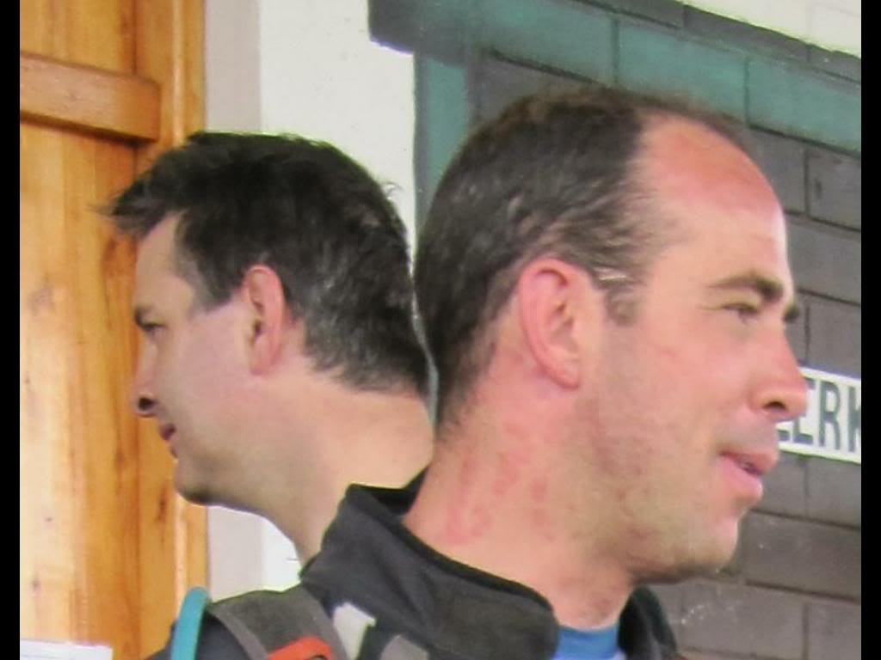
18. He did a perfect salto... with his bike on tow! We were told when the GS's arrived at Beestekraal stasie.
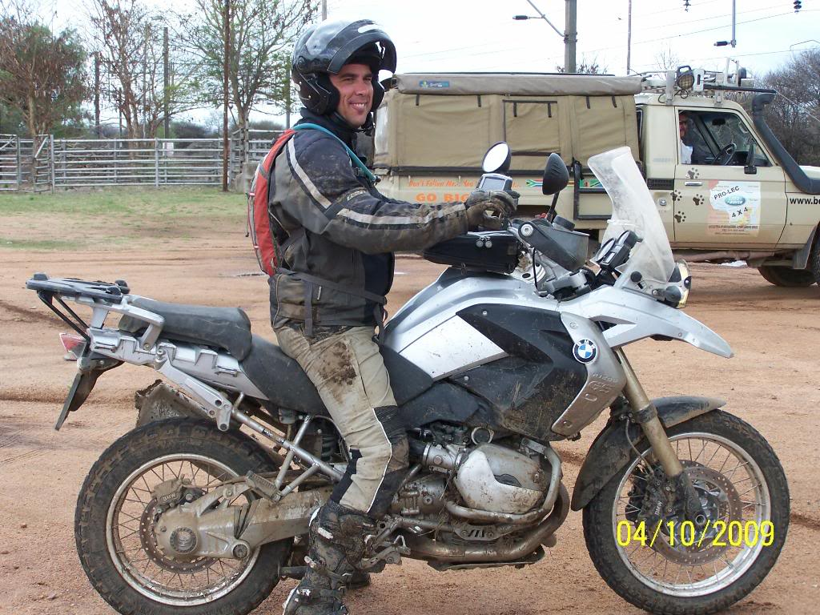
19. Fauna & Flora is watching, sir. We have Green Scorpions in this country too, you know... And they usually lock you up on Fridays, for the whole weekend!!!!
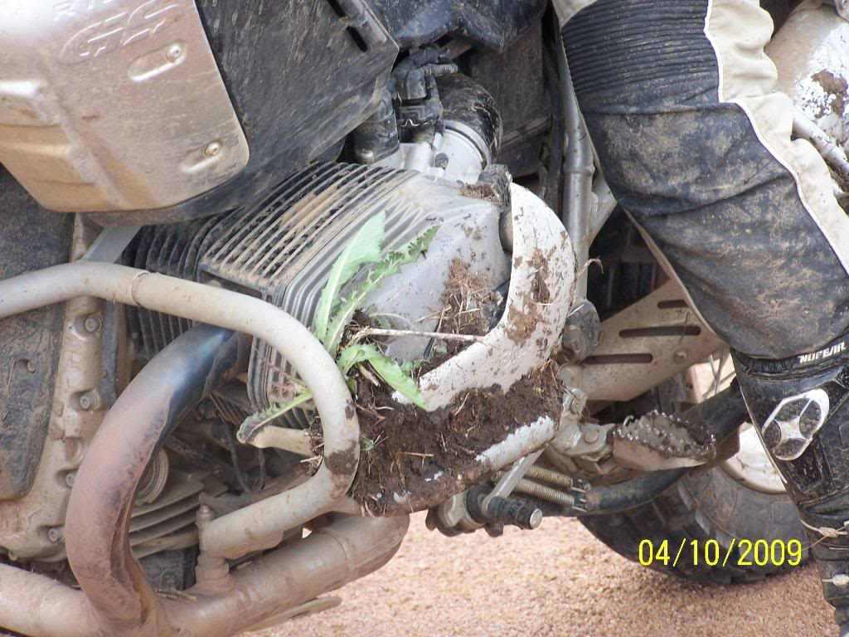
13. An RT can spin...
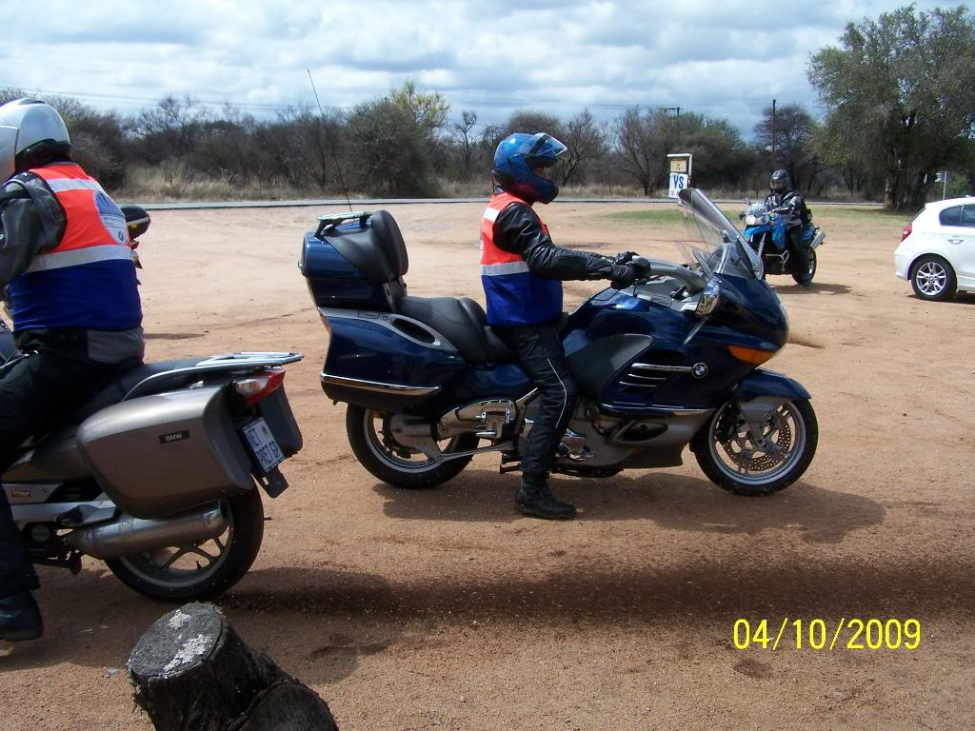
14. Showing off preference
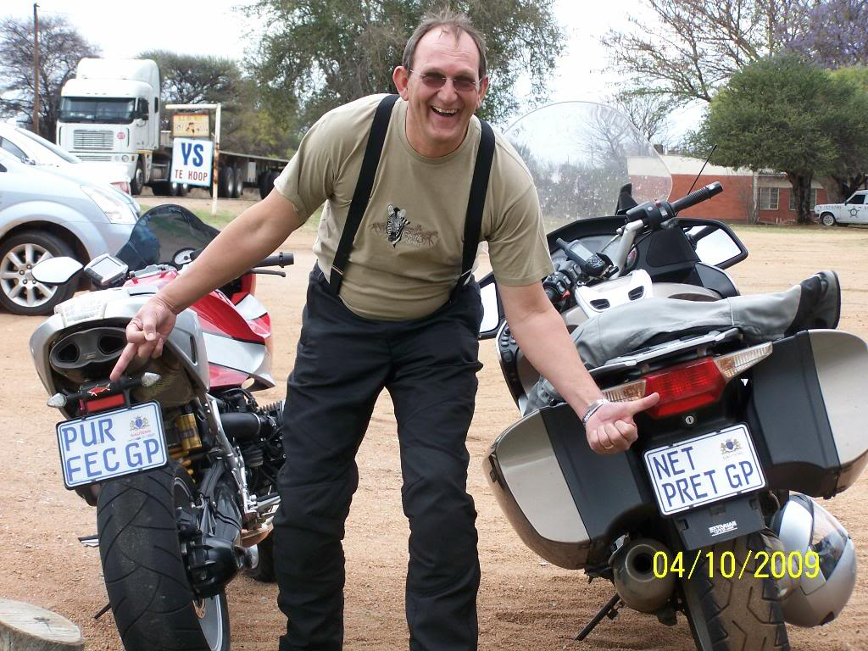
15a. The assembly without the near table.... Dave enquiring who'se contact lense he's got on the finger . Elaine's father and mother (on the left) joined the breakie on a short visit from Berlin, Germany. Flying back tomorrow. Also Sue's mom just behind Dave. Nice kids you have here, folks!
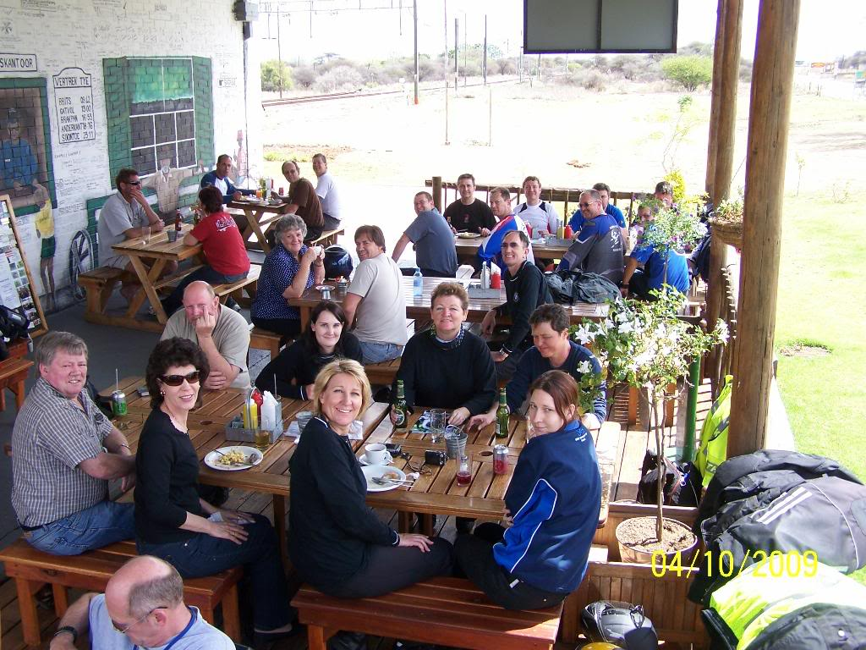
15. The near table... with my other favourite on the left
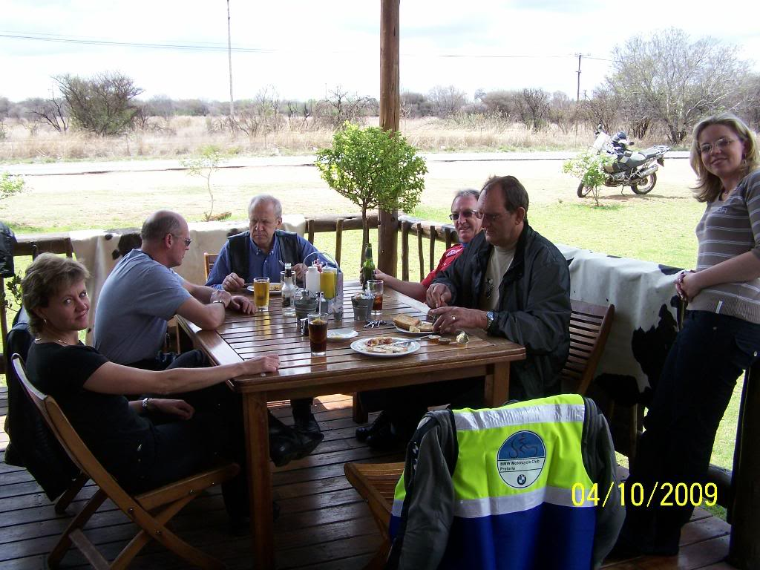
16. Beestekraal Stasie at its best, with bikes allover and owner Lynette at the helm. Thanks Lynette, the Breakie was splendid. And at R50 a head, wow!
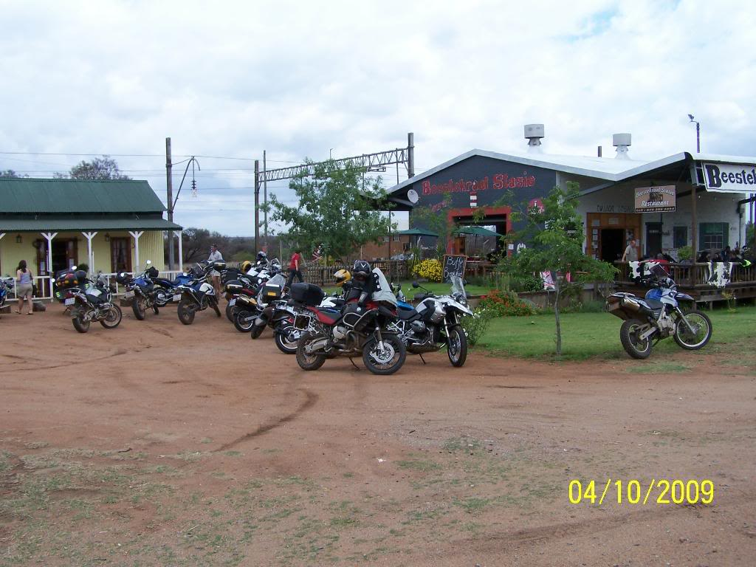
17. Abe, our Graffiti Master. In skoonskrif. ( You can see he started off as a Draughtsman! )
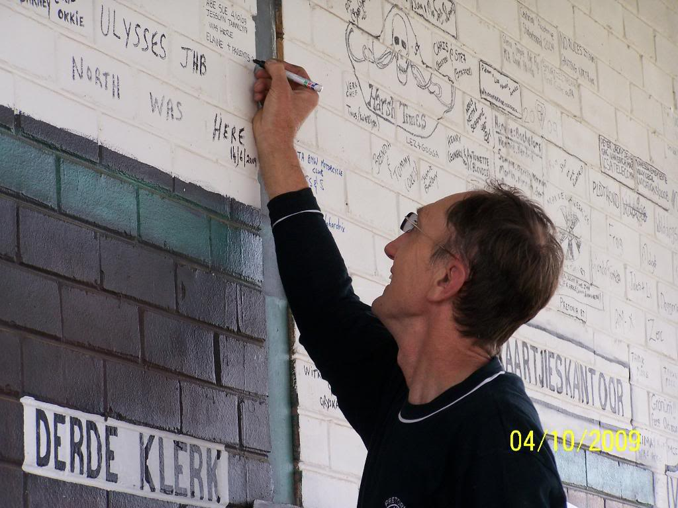
20. Dis reg, Elaine. Ons gaan mos nie spoeg nie, né?
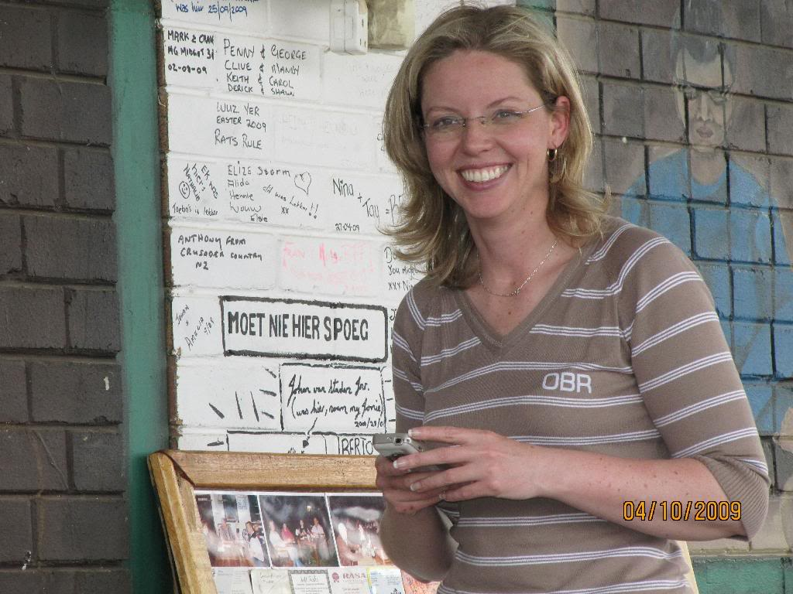
Dankie aan almal wat gedeel het. Dit was weereens 'n fees om saam julle te ry en te kuier

