3 Tvl Dams and canopy tour..
by DaveS on 27th September 2009, 20:11
Seeing that nobody wants to start a 'report' for this trip I will post some 'teasers'. I only joined the group on Thursday afternoon so will hold off with other pics and days events until someone has reported on the Thursday ride.....but in the meantime....just to whet the appetite..
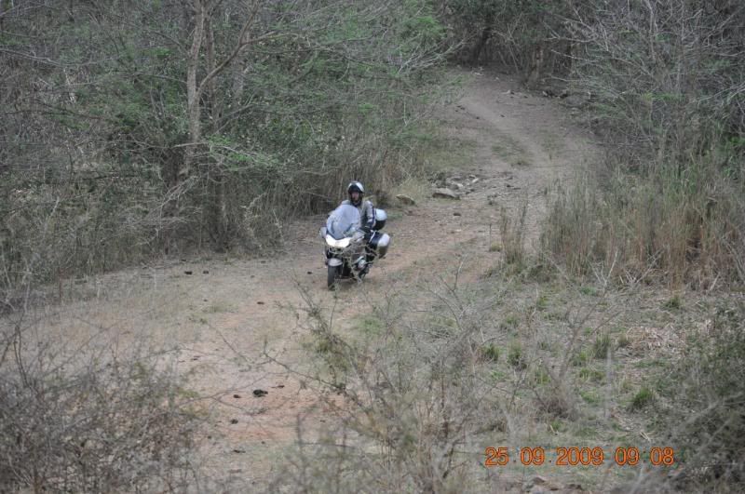
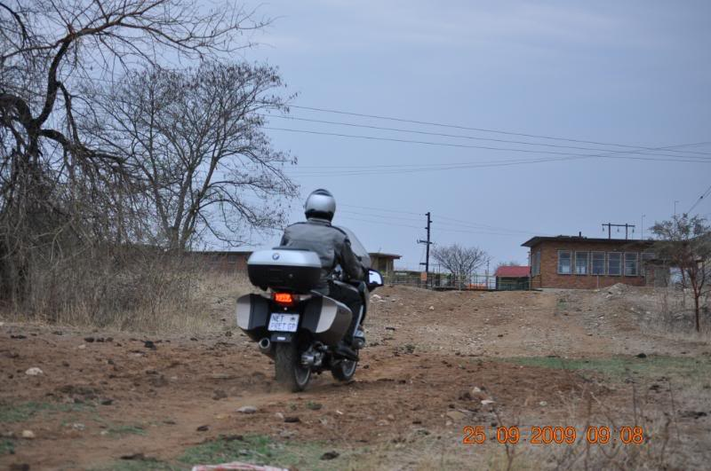
For now I will just say nothing...
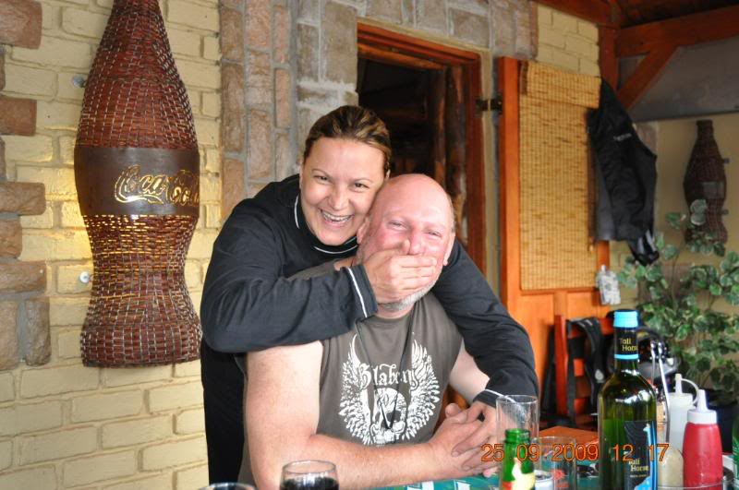
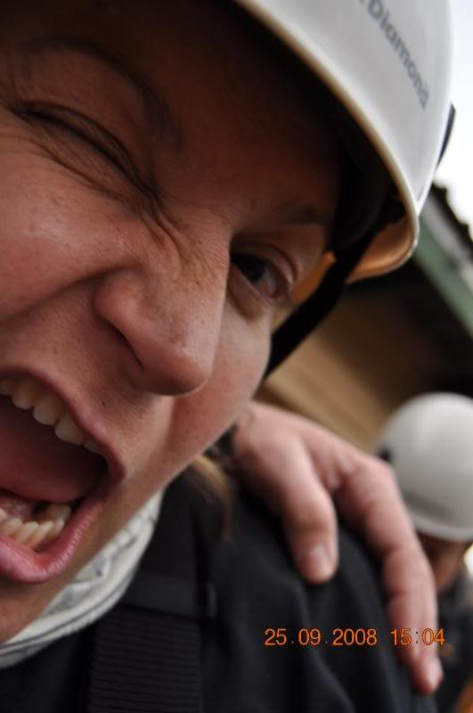
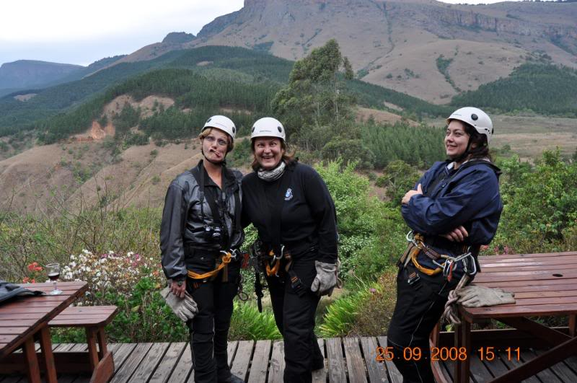
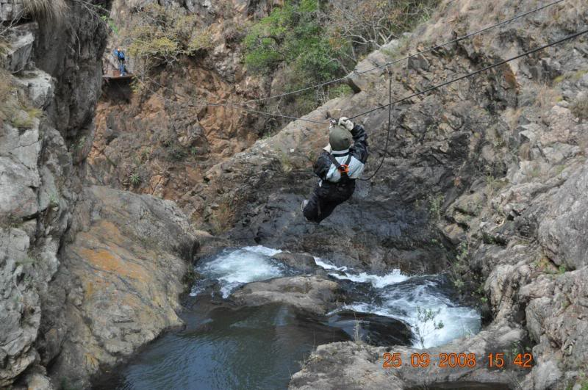
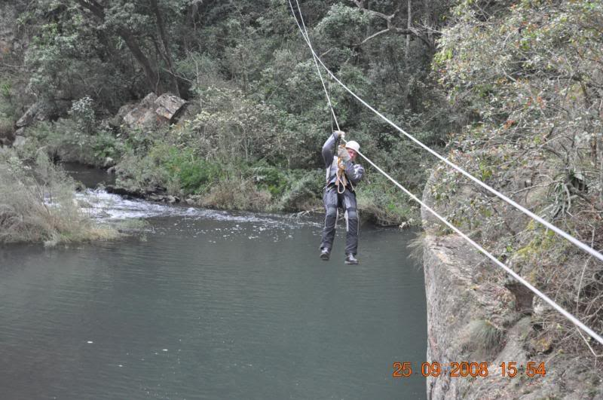
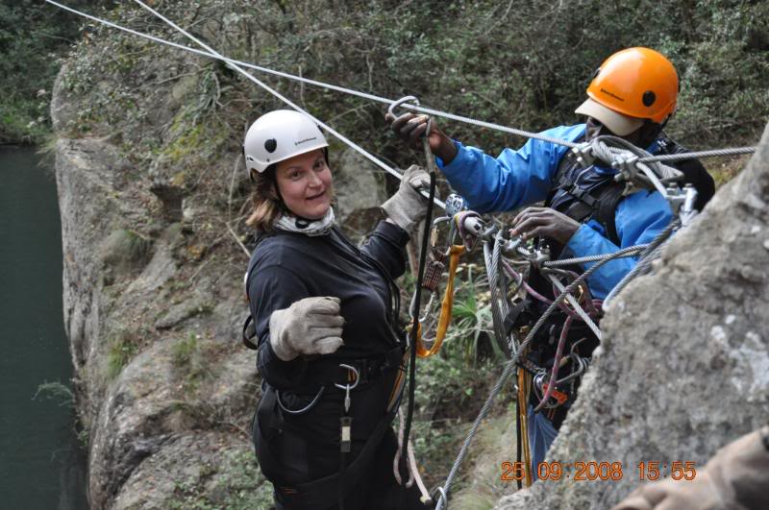
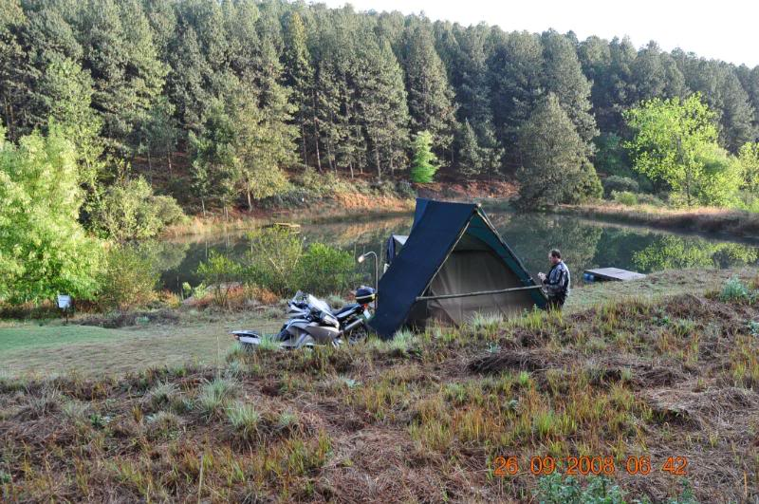
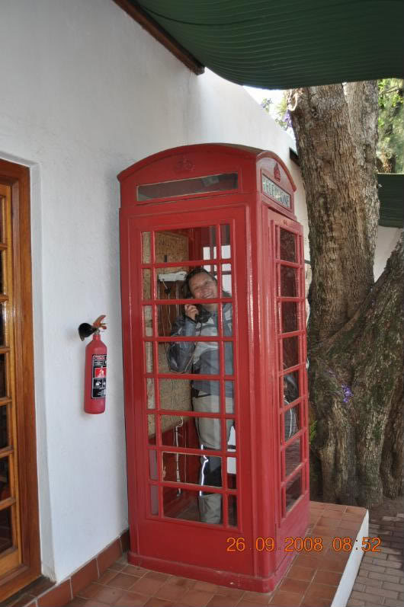
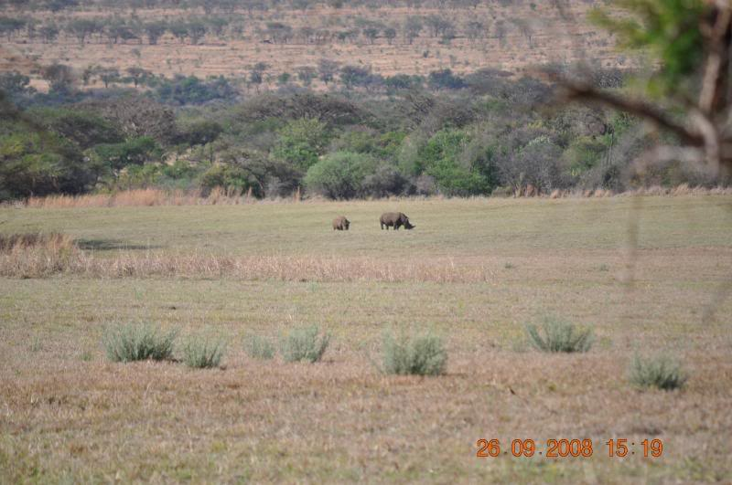
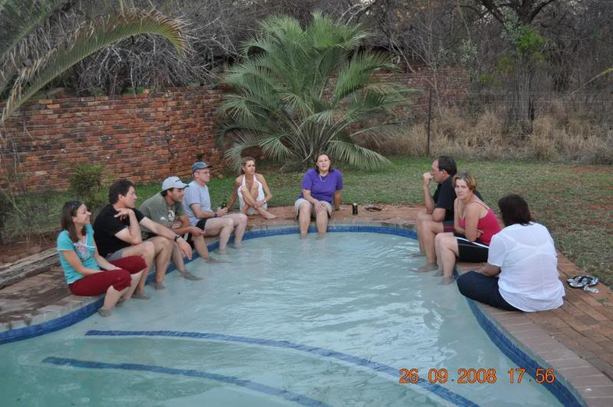
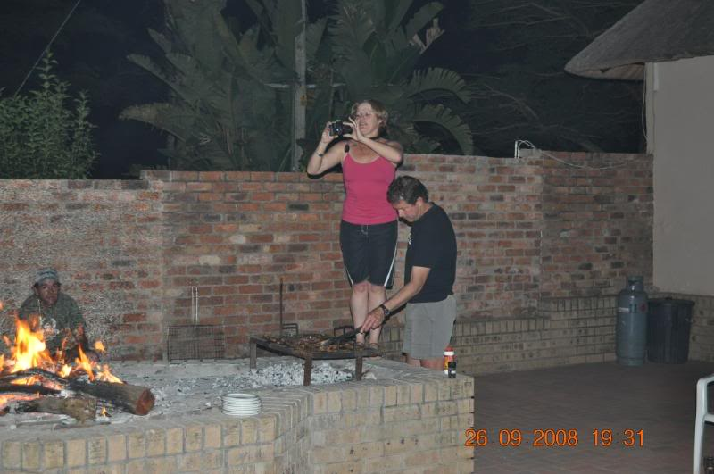
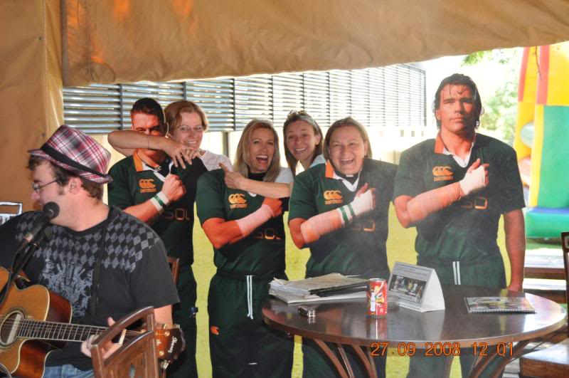
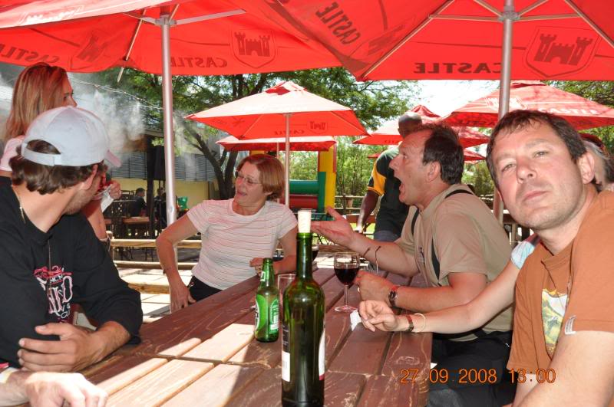
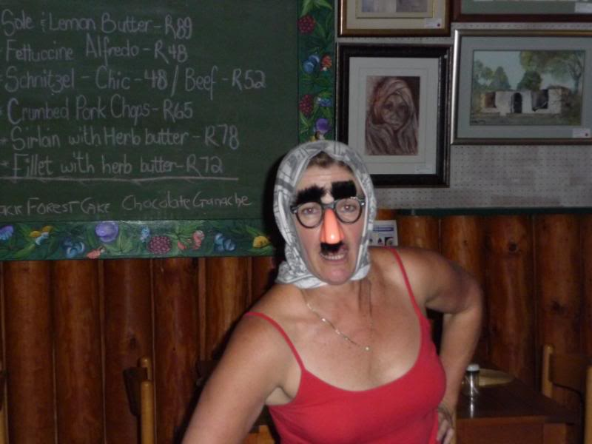
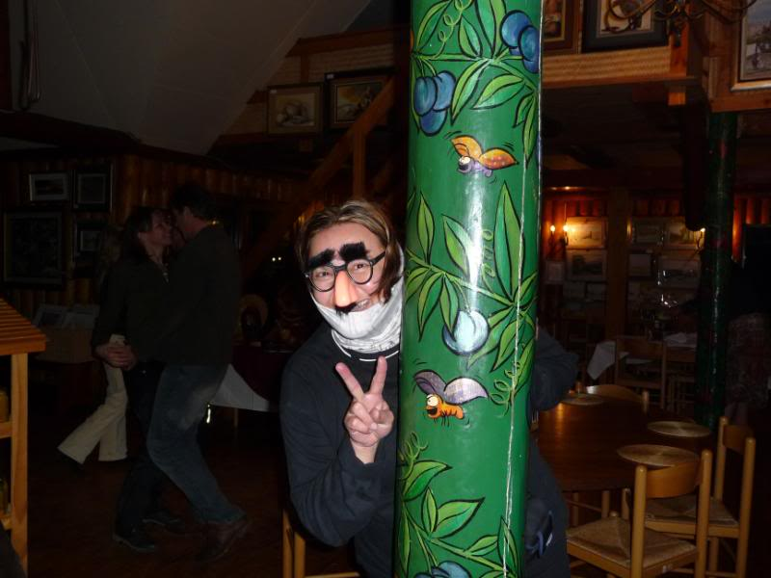
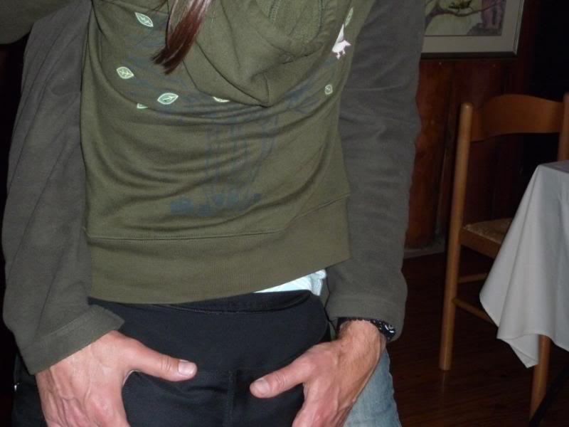
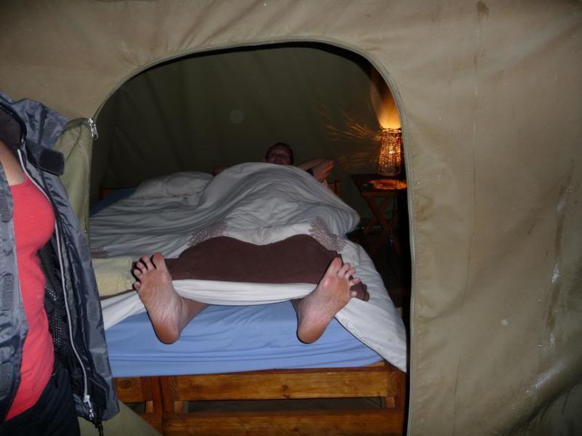
....and lastly...the 'do not disturb' sign outside one of the chalets....
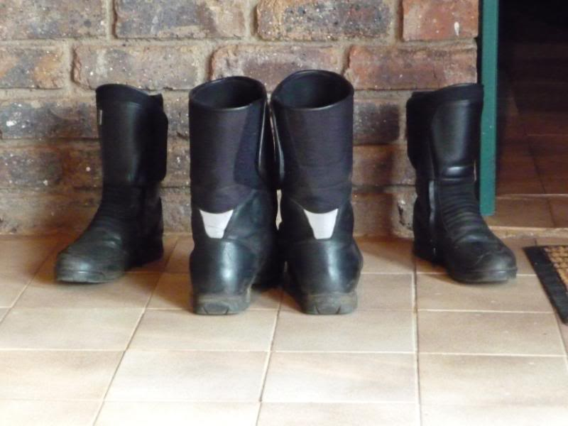
but at least everyone was game..
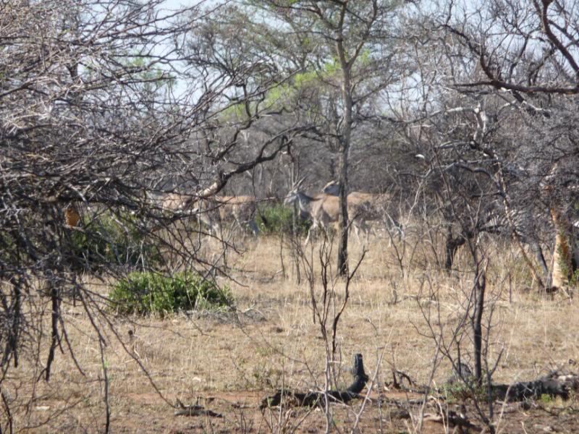
thanks Johan and Trudi for a good trip..
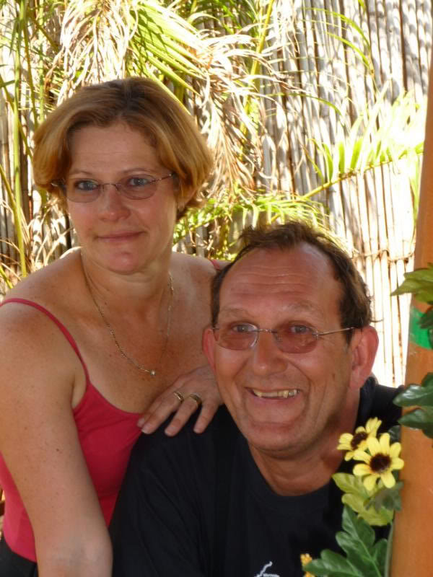
and be sure to be on the lookout for the rest of the report...
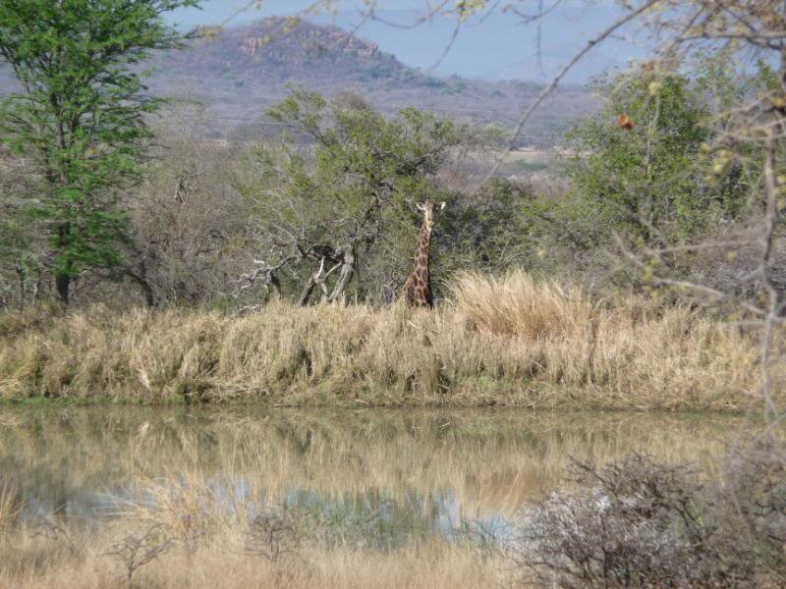
_________________
When I was born I was so surprised I didn't talk for a year and a half!
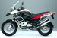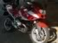
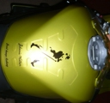
DaveS
Committee member

Re: 3 Tvl Dams and canopy tour..
by DotP on 27th September 2009, 20:40
Hmmmm!!! Jissie jong.... photo's but no comments!!! Is this a case of what goes on tour, stays on tour or shall we wait for the running commentary!?!?
Johan and Truds - DANKIE dit was weereens 'n uitstekkende trip! Moontlik alweer "rooiwyn" vergiftiging maar niks wat 'n ou pyn pilletjie nie kan uitsort nie
Vir al die ander mense - bekendes en onbekendes (Susan, Andrea, Danie en Wilmien), nice to have met you. Great laughs, great riding and great company! Hoop julle join ons somer gou weer!
_________________
When everything comes your way, you're in the wrong lane.
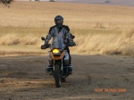
DotP
Fuel Injected

Re: 3 Tvl Dams and canopy tour..
by JR on 27th September 2009, 21:00
Now this is what I call an interesting and thought provoking appetizer.
Sou bitter graag meer wou lees van julle trip......of is daar ‘n ouderdomsperk op?
.....maak dan maar net soos die "ingelsman"......plaas net die prentjies – ons sal self die “bubbles” insit
_________________
Let's go forward........the road is calling anyway
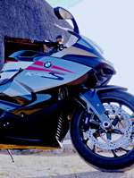
JR
The K-factor

Re: 3 Tvl Dams and canopy tour..
by tj on 27th September 2009, 21:03
The purpose of this trip was to see for ourselves what the state of water levels are at the three large dams inside Transvaal, and to do the Canopy Tour in Magoebas Kloof while we are at it.
It makes no sense to ride aimlessly without a destiny. All the burnt fuel & money and adding to the carbon footprint! . One needs a destiny and purpose!
First the dams:
Harties
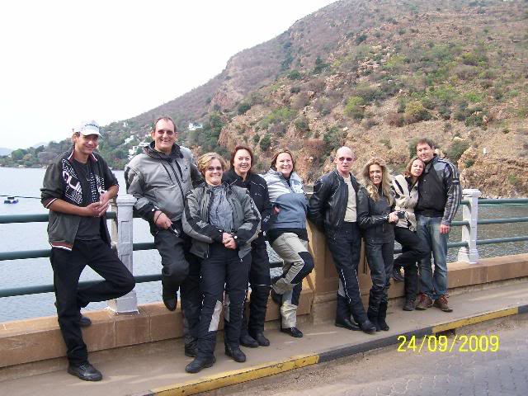
Middle Letaba
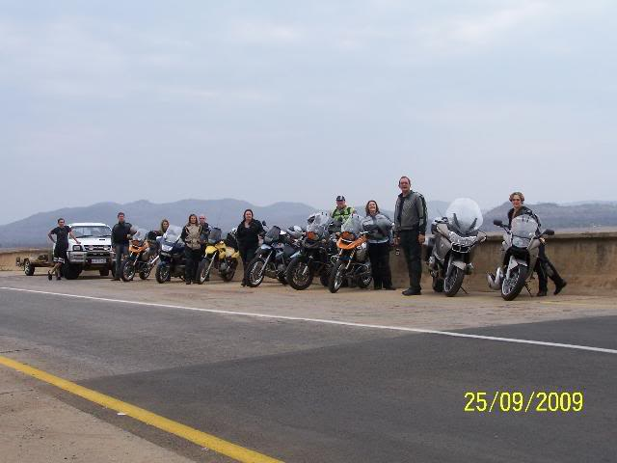
Loskop
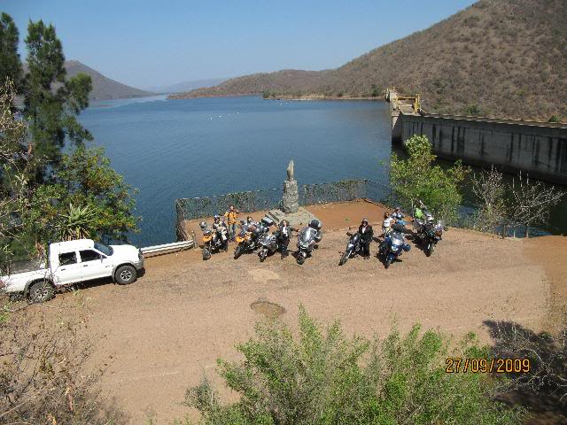
Harties & Loskop are very near to over-flowing while M Letaba is under the empty line due to a severe drought in the area. No water is let out to the agricultural community it serves.
OK. Formalities over now the real spirit of this trip
The Canopy Tour:
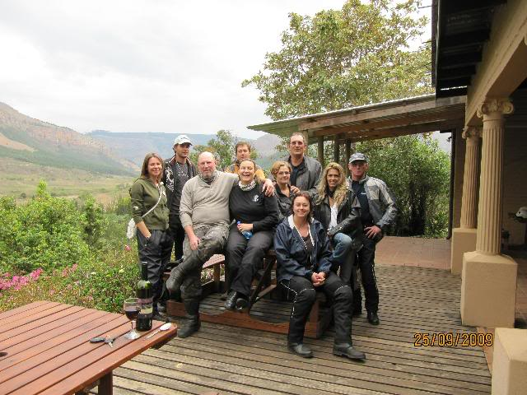
Kitting out
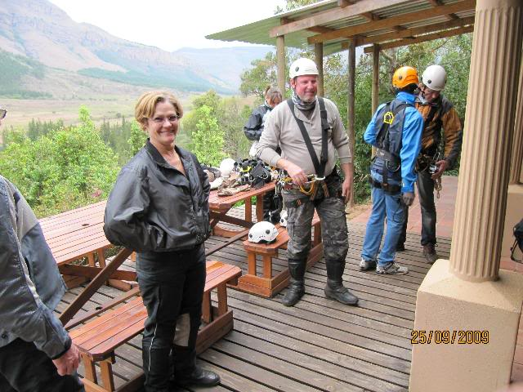
Mechanical issues
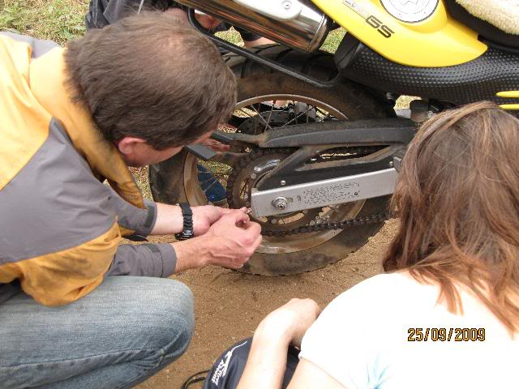
The chain eventually gave way and the backup with Johan Jnr as driver were called in. Andrea really wanted to proceed on her bike!
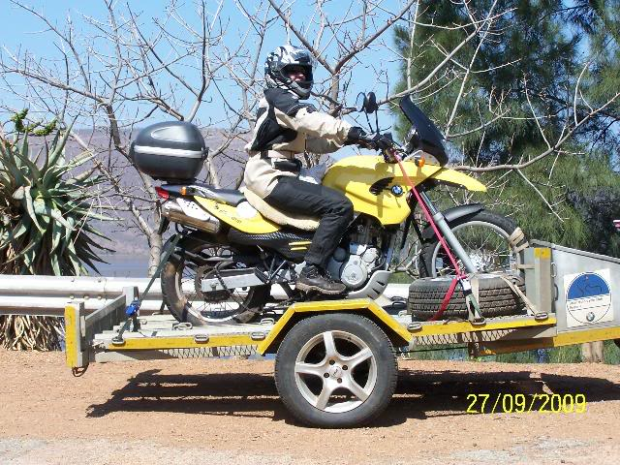
She later resorted to pillion on Danie's bike. He didn't mind the compulsory hugs.
We at first thought they are boetie & sussie...
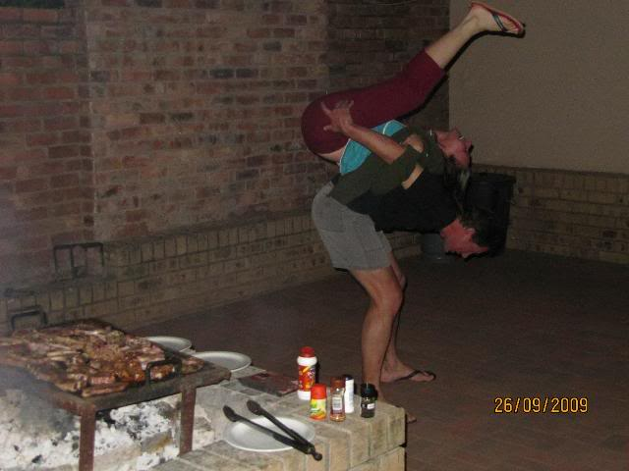
...but then they were just too much lovey-dovey...
Do NOT DISTURB!!!!!!!!
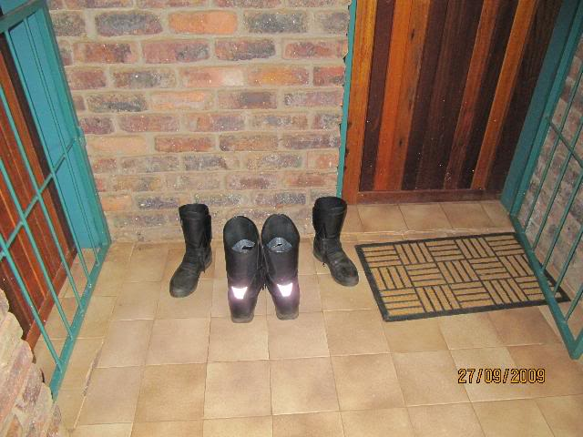
We stayed over the first night at Mopani Lodge in Giyani and prepared our own braai that evening next to the pool. Everybody was positive to take a dive as it was quite warm that evening. We only reached as far as the calves, on the first step. The water being still too cold!
The second night at Thaba-Metsi in Magoebas Kloof after the Canopy tour in their tented camp. In the rainy conditions we had protection against the elements but that was just about all. Would've been nice if we had better weather that day.
Our campsite
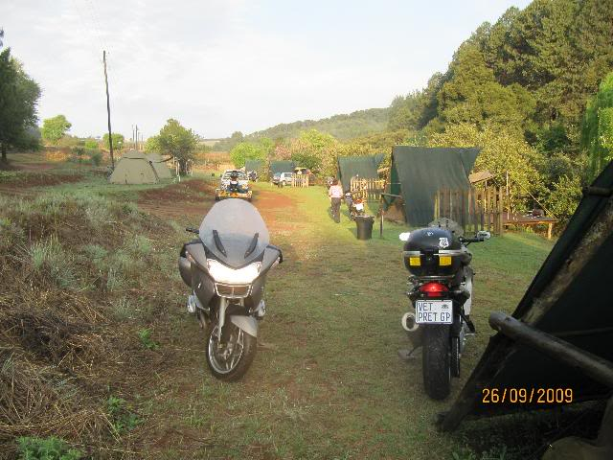
That afternoon we killed time before the Canopy Tour at Iron Crown and Nadia was serving us
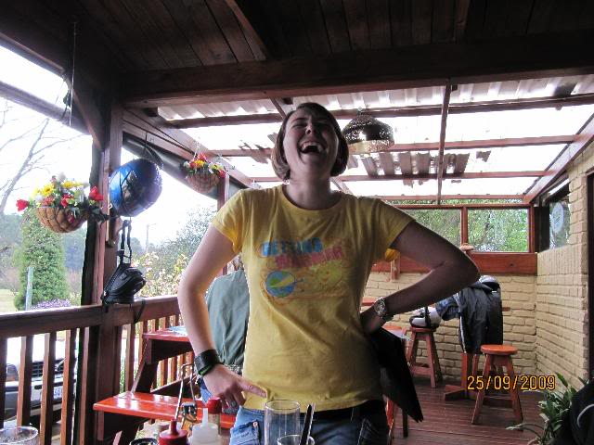
Her description of a bisexual relationship: " A friendship with benefits" - Excellent!!
That evening we enjoyed dinner at Picasso's in Heanertsburg. Riding in the rain to town and back to camp. Yes we can. This turned out to be quite interesting...
The faces
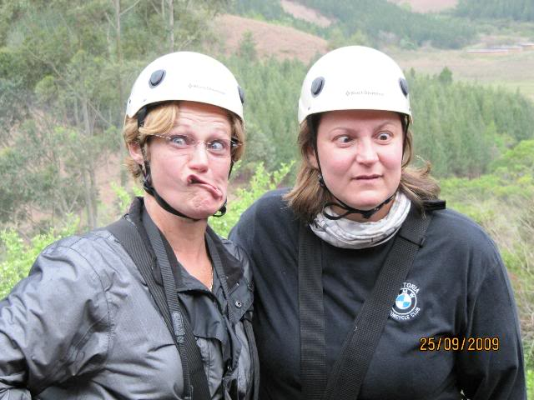
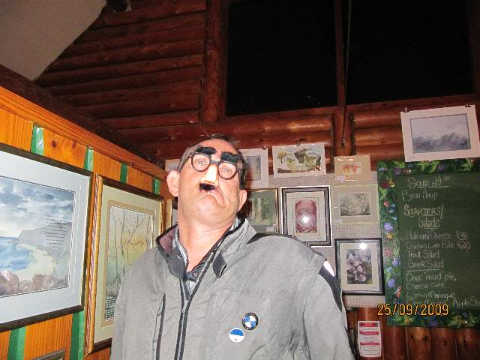
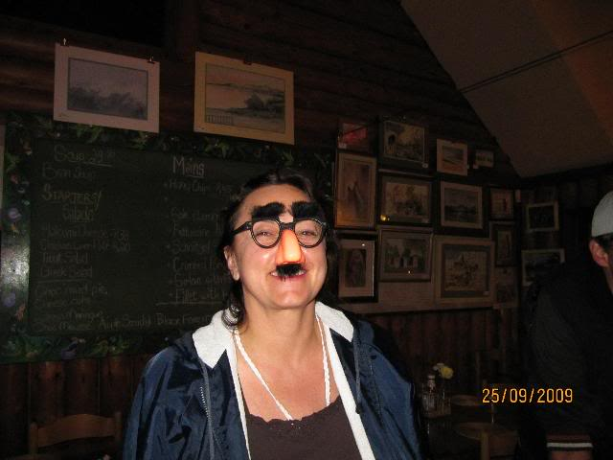
The ride.
All roads were quite passible, from excellent newly tarred highway to passes and sweeps, in the rain and not...
...and GS!
By a GS
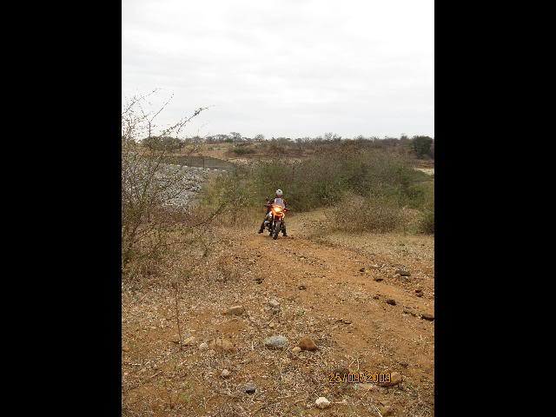
...and by an RT!!!!!!!!!!
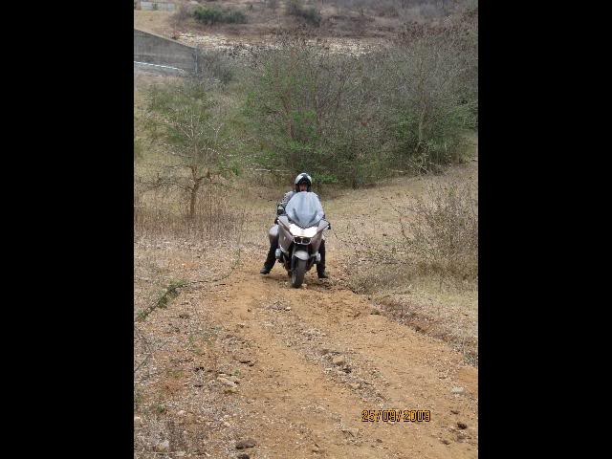
En route we saw affordable stones. Of those we all may need only once in our lives
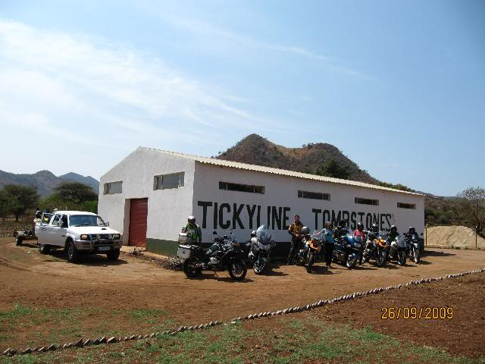
With low maintenance

We stopped at the Coach House Hotel in Agatha for breakfast as we did not even could get coffee at the tented camp. Five Stars!!! While the ladies wasted time in the kiosk we showed our attitude
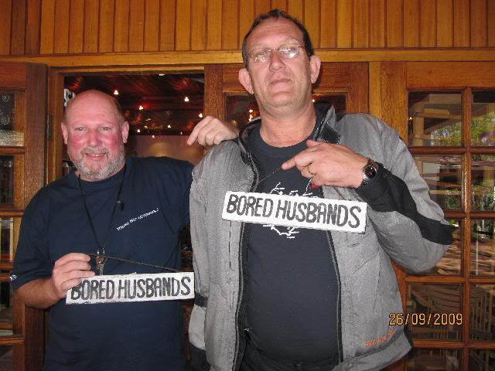
The last night we stayed over at the magnificent Marula Lodge, 10km Out from Groblersdal. That evening we (the ladies) again prepared a meal for a king and Danie and Johan Jnr did the fire and braai thing
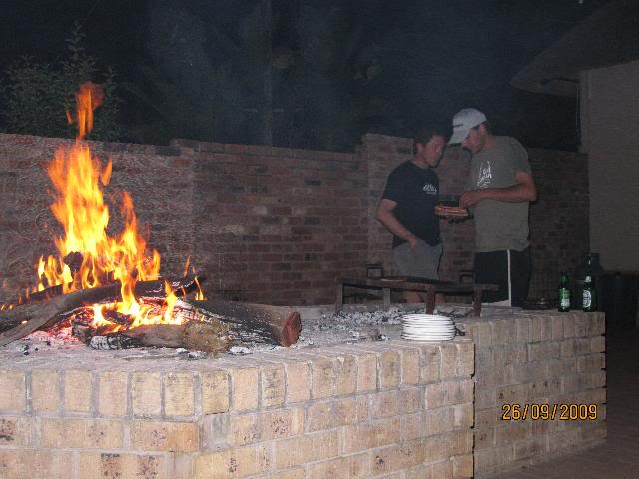
While Susan is chatting to Frik outside the picture, Dave is looking on. Wat kyk jy Dawid?
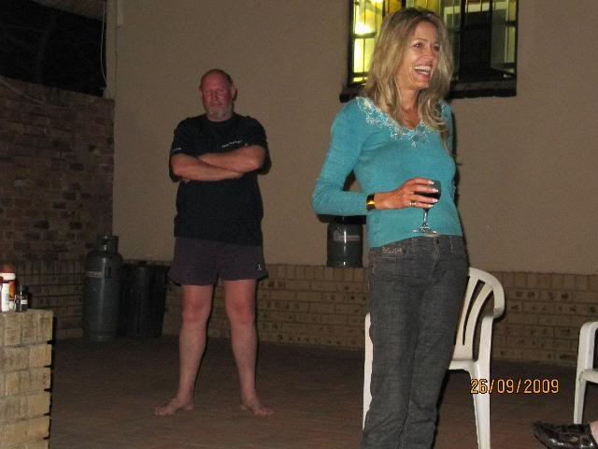
Early the last morning the group went on a game drive
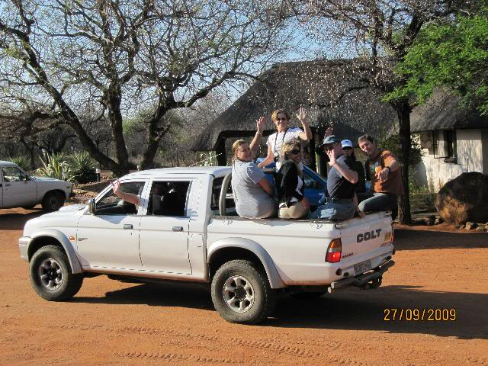
It is difficult to tell the whole story with pictures.
All I can say is: The company made this a splendid trip. Thank you all and well done
Last edited by tj on 27th September 2009, 21:25; edited 1 time in total

